BACHELOR OF INFORMATION TECHNOLOGY (HONS.) IN COMPUTER SYSTEM SECURITY

Secure messaging with zero knowledge proof and intelligent threat detection

MOHAMMAD AZRI BIN AZIZ
52215123264

MALAYSIAN INSTITUTE OF INFORMATION TECHNOLOGY
UNIVERSITI KUALA LUMPUR

MARCH 2026

Secure messaging with zero knowledge proof and intelligent threat detection

MOHAMMAD AZRI BIN AZIZ
52215123264

Report Submitted to Fulfill the Partial Requirements
For the Bachelor of Information Technology (Hons.) in Computer System Security
Malaysian Institute of Information Technology
University Kuala Lumpur

March 2026
DECLARATION

I declare that this repost is my original work and all references have been cited adequately as required by the University
Date: 12/6/2026 | Signature  Full Name:  ID Number: |   ......................................  MOHAMMAD AZRI BIN AZIZ  52215123264
APPROVAL PAGE

We have supervised and examined this report and verified that it meets the program and University’s requirements for the Bachelor of Information Technology (Computer System Security) Honours.

Date: 12/6/2026 | Signature  Supervisor: Official Stamp: | ......................................  DR DELINA BEH MEI YIN
Date: 12/6/2026 | Signature  Accessor 1:  Official Stamp:  (Optional) | ......................................  PROF. DR. MEGAT FAREEZ AZRIL ZUHAIRI
DEDICATION

To my beloved parents, whose endless love, prayers, and sacrifices have carried me through every step of this journey.
To my family and friends, for their constant encouragement and unwavering belief in me.
To my supervisor, Dr Delina Beh Mei Yin, for her invaluable guidance, patience, and inspiration.
And to everyone who supported me along the way — thank you.
ACKNOWLEDGEMENT
My deepest thanks go first to my supervisor, Dr Delina Beh Mei Yin. Throughout this Final Year Project she offered guidance, patience, and steady encouragement, and her insight and constructive feedback did much to shape both the direction and the quality of the work.
I am also sincerely grateful to the assessors and to the lecturers of the Bachelor of Information Technology (Hons.) in Computer System Security programme at Universiti Kuala Lumpur. Their knowledge and support gave this project the foundation it was built on.
Thanks are due as well to the management and staff of NISHA SUTERA PRIMA. They were willing to take part in the user acceptance testing, and they offered practical insights into the real-world communication needs of a small enterprise.
Finally, I am profoundly grateful to my family and friends. Their moral support, understanding, and motivation never wavered through my studies, and this accomplishment would not have been possible without them.

Table Of Content
CHAPTER 1 19
INTRODUCTION 19
1.1 Introduction 19
1.2 Background of the Study 20
1.3 Problem Statement 22
1.4 Objectives 23
1.5 Project Scope 25
1.6 Significant of The Projects 27
1.7 Organization of the Report 29
CHAPTER 2 31
LITERATURE REVIEW 31
2.1 Introduction 31
2.2 Overview of Secure Enterprise Messaging 32
2.3 Zero Knowledge Proofs (Authentication) 32
2.3.1 Privacy Preserving Authentication 32
2.3.2 Feasibility on Resource-Constrained Devices 33
2.3.3 Application in Identity and Data Integrity 34
2.4 End-to-End Encryption (E2EE) Protocols 35
2.4.1 Vulnerabilities in Authentication Ceremonies 35
2.4.2 The Insider Threat Landscape 35
2.4.3 Architecture and Scalability 36
2.5 On-Device AI Anomaly Detection 37
2.5.1 The Shift to Edge Computing 37
2.5.2 Mobile Optimization Techniques 37
2.6 Summary and Research Gap 38
2.7 Conclusion 39
CHAPTER 3 40
METHODOLOGY 40
3.1 Introduction 40
3.2 Overview of Software Development Models 40
3.2.1 Waterfall Model 41
3.2.2 Agile Model 42
3.2.3 Rapid Application Development (RAD) 43
3.3 Proposed Methodology 44
Justification for Choosing RAD 44
3.4 Phases of Development 46
3.4.1 Phase 1: Requirements Planning 46
3.4.2 Phase 2: User Design 46
3.4.3 Phase 3: Construction 52
3.4.4 Phase 4: Cutover 53
Integration Testing: 53
Security Audits: 53
User Acceptance Testing (UAT): 53
3.5 System Requirements 54
3.5.1 Hardware Requirements 54
3.5.2 Software Requirements 55
3.5.3 Budget and Costing 56
3.6 Project Planning 57
Gantt Chart Link: Excel_File_Link 57
3.7 Chapter Summary 58
CHAPTER 4 59
SYSTEM DEVELOPMENT 59
4.1 Introduction 59
4.2 Development Environment and Tools 60
4.2.1 Hardware and Operating System 60
4.2.2 Integrated Development Environments and Tooling 61
4.2.3 Frameworks, Languages and Runtimes 61
4.2.4 Software Dependencies 62
4.3 System Architecture as Implemented 65
4.4 Installation, Setup and Configuration 68
4.4.1 Backend Server Setup 68
4.4.2 Zero-Knowledge Circuit Compilation and Trusted Setup 69
4.4.3 Web Portal Setup 69
4.4.4 Mobile Application Setup 69
4.4.5 Machine-Learning Pipeline Setup 70
4.5 Implementation of the Core Security Modules 70
4.5.1 Module A: Zero-Knowledge Proof Authentication 70
4.5.2 Module B: End-to-End Encrypted Messaging 74
4.5.3 Module C: On-Device AI Threat Detection 76
4.6 User Interface and Experience Design 81
4.7 System Integration 83
4.8 Source-Code Management and Version Evolution 86
4.9 Deployment Environment 87
4.10 Chapter Summary 88
CHAPTER 5 89
RESULT AND DISCUSSION 89
5.1 Introduction 89
5.2 Testing Methodology and Environment 90
5.3 Functional Testing 91
5.4 Security Testing 92
5.4.1 Confidentiality 92
5.4.2 Integrity 93
5.4.3 Availability 94
5.4.4 Authentication, Authorisation and Accounting (AAA) 95
5.5 Vulnerability and Static Scanning 96
5.6 Machine-Learning Detection Performance 96
5.7 Performance and Latency 101
5.8 User Acceptance Testing 102
5.9 Discussion 104
5.10 Chapter Summary 105
CHAPTER 6 106
CONCLUSIONS AND RECOMMENDATIONS 106
6.1 Introduction 106
6.2 Achievement of the Project Objectives 106
6.3 Conclusion of the Project 108
6.4 Limitations of the Project 109
6.5 Recommendations for Future Work 110
6.6 Commercialization 111
6.7 Concluding Remarks 112
REFERENCES 113
APPENDIX A: LETTER OF ACCEPTANCE (LOA) 115
APPENDIX B: SOURCE CODE REPOSITORY 120

LIST OF FIGURES
Figure 2.3.1.1: Zero-Knowledge Proof Sequence Diagram 33
Figure 3.2.1.1: Diagram Waterfall Model 41
Figure 3.2.2.1: Diagram Agile Model 42
Figure 3.2.3.1: Diagram Rapid Application Development (RAD) Model 43
Figure 3.4.2.1: SentriZK System Architecture 47
Figure 3.4.2.2: SentriZK Sequence Diagram 48
Figure 3.4.2.3: SentriZK Flow Chart 49
Figure 3.4.2.4: SentriZK Use Case Diagram 50
Figure 3.4.2.5: SentriZK Misuse Case Diagram 51
Figure 3.6.1: Project Gantt Chart Summary 57
Figure 4.1: SentriZK Full System Architecture (as implemented) 61 66
Figure 4.2: Component Diagram of the Flutter Mobile Application 62 67
Figure 4.3: Zero-Knowledge Registration Flow 67 72
Figure 4.4: Zero-Knowledge Login Flow with Nonce-Bound Session 68 73
Figure 4.5: Signal Protocol End-to-End Encrypted Messaging 70 75
Figure 4.6: On-Device TensorFlow Lite Threat-Detection Pipeline 73 78
Figure 4.7: URL Phishing-Detection Architecture 75 80
Figure 4.8: Mobile Application User Interface (representative screens) 76 81
Figure 4.9: Web-Based Administrator Panel 77 82
Figure 4.10: SentriZK Web Administrator Panel (Live Interface) 78 83
Figure 4.11: Session Lifecycle and Security 80 85
Figure 4.12: Deployment and Infrastructure Architecture 82 87
Figure 5.1: Per-Class Classification Metrics (Bi-LSTM vs Conv1D) 92 97
Figure 5.2: Confusion Matrices on the 1,148-Message Validation Set 93 98
Figure 5.3: Model Performance Comparison Against the 90% Target 93 98
Figure 5.4: Predicted Threat-Score Distribution by True Class (Conv1D) 94 99
Figure 5.5: Receiver Operating Characteristic (ROC) Curves 95 100
Figure 5.6: User Acceptance Testing - Mean Score per Question (n = 5) 98 103
LIST OF TABLES
Table 3.5.3.1: Project Cost Breakdown 56
Table 4.1: Development and Test Hardware 55 60
Table 4.2: Core Framework of Each System Tier 56 61
Table 4.3: Principal Backend Dependencies 57 62
Table 4.4: Principal Web Portal Dependencies 57 57 62
Table 4.5: Principal Mobile Application Dependencies 58 58 63
Table 4.6: Backend Environment Configuration 63 68
Table 4.7: Zero-Knowledge Circuit Parameters 66 71
Table 4.8: On-Device Threat-Detection Model 72 77
Table 4.9: Iterative Version Evolution of the Prototype 81 86
Table 5.1: Overview of Testing Types 85 90
Table 5.2: Functional Test Cases and Results 86 91
Table 5.3: Confidentiality Test Results 88 93
Table 5.4: Integrity Test Results 89 94
Table 5.5: Availability Test Results 90 95
Table 5.6: AAA Model Mapped to Implemented Controls 90 95
Table 5.7: Dependency Vulnerability Scan (npm audit) 91 96
Table 5.8: Model Performance Comparison 92 97
Table 5.9: Machine-Learning Detection Functional Tests 96 101
Table 5.10: Indicative Performance Measurements 96 101
Table 5.11: User Acceptance Questionnaire and Mean Results 97 102
Table 5.12: Individual Participant Responses (n = 5) 98 103
Table 6.1: Achievement of the Project Objectives 102 107
Table 6.2: Limitations and Corresponding Recommendations 105 110
LIST OF ABBREVIATIONS
Abbreviation | Definition
AAA | Authentication, Authorisation and Accounting
AES | Advanced Encryption Standard
AI | Artificial Intelligence
API | Application Programming Interface
APK | Android Package Kit
AUC | Area Under the Curve
BIP-39 | Bitcoin Improvement Proposal 39 (mnemonic standard)
CBC | Cipher Block Chaining
CIA | Confidentiality, Integrity and Availability
CNN | Convolutional Neural Network
Conv1D | One-Dimensional Convolutional Neural Network
DTLS | Datagram Transport Layer Security
E2EE | End-to-End Encryption
ECDH | Elliptic Curve Diffie-Hellman
FCM | Firebase Cloud Messaging
GCM | Galois/Counter Mode
GDPR | General Data Protection Regulation
HKDF | HMAC-based Key Derivation Function
HMAC | Hash-based Message Authentication Code
HSM | Hardware Security Module
IDE | Integrated Development Environment
JWT | JSON Web Token
LSTM | Long Short-Term Memory
MAT | Mobile Access Token
MFA | Multi-Factor Authentication
MITM | Man-in-the-Middle
ML | Machine Learning
PBKDF2 | Password-Based Key Derivation Function 2
PDPA | Personal Data Protection Act
RAD | Rapid Application Development
ROC | Receiver Operating Characteristic
SHA | Secure Hash Algorithm
SME | Small and Medium Enterprise
SRTP | Secure Real-time Transport Protocol
SSE | Server-Sent Events
TFLite | TensorFlow Lite
TLS | Transport Layer Security
TOFU | Trust On First Use
UAT | User Acceptance Testing
UI | User Interface
UX | User Experience
WebRTC | Web Real-Time Communication
X3DH | Extended Triple Diffie-Hellman
ZKP | Zero-Knowledge Proof
zk-SNARK | Zero-Knowledge Succinct Non-Interactive Argument of Knowledge
ABSTRACT
Securing internal messaging remains a stubborn problem for small and medium enterprises (SMEs). They depend on collaboration tools that keep user credentials on centralised servers and that lose sight of threats the moment messages are encrypted. This dissertation presents SentriZK, a secure internal chat application that settles the conflict between privacy and security by bringing together three technologies: Zero-Knowledge Proof (ZKP) authentication, end-to-end encryption (E2EE), and on-device artificial intelligence (AI) threat detection. It was built with the Rapid Application Development methodology and comprises a Flutter mobile application, a Next.js web portal, a Node.js backend, and a Python machine-learning pipeline. Authentication sends no passwords at all. It relies on Groth16 zk-SNARK circuits whose proofs are generated through a single-use Mobile Access Token bridge, so the server holds only mathematical commitments. Messages are protected with the Signal Protocol, which provides forward secrecy, while a quantised convolutional neural network embedded in the application scans messages for phishing and social-engineering threats entirely on the device, preserving privacy. The finished prototype was evaluated through functional, security, performance, and user-acceptance testing. Every functional test case passed, and the system withstood nineteen automated and sixteen manual adversarial security tests organised around the Confidentiality-Integrity-Availability triad, defending against credential theft, proof forgery, replay, session hijacking, reverse engineering, traffic interception, and denial-of-service attacks. The on-device detection model reached an accuracy of 89.2 per cent and an area under the ROC curve of 96.2 per cent, all in a model of under one megabyte. Cryptographic operations proved feasible on consumer hardware, and the system earned an overall user-acceptance rating of 4.32 out of 5. These results show that an SME need not choose between protecting employee privacy and detecting threats; both can be achieved at once on affordable, self-hosted infrastructure. The project contributes a working blueprint for privacy-preserving, intelligent, and low-cost secure messaging, and it points to clear directions for future work, among them behavioural anomaly detection and post-quantum cryptography.
ABSTRAK

Menjamin keselamatan pemesejan dalaman kekal menjadi masalah yang sukar bagi perusahaan kecil dan sederhana (PKS). Mereka bergantung pada alat kolaborasi yang menyimpan kelayakan pengguna pada pelayan berpusat dan hilang keupayaan untuk mengesan ancaman sebaik sahaja mesej disulitkan. Disertasi ini memperkenalkan SentriZK, sebuah aplikasi sembang dalaman selamat yang menyelesaikan konflik antara privasi dan keselamatan dengan menggabungkan tiga teknologi: pengesahan Zero-Knowledge Proof (ZKP), penyulitan hujung-ke-hujung (E2EE), dan pengesanan ancaman kecerdasan buatan (AI) atas peranti. Ia dibina menggunakan metodologi Rapid Application Development dan terdiri daripada aplikasi mudah alih Flutter, portal web Next.js, bahagian belakang Node.js, dan saluran pembelajaran mesin Python. Pengesahan tidak menghantar sebarang kata laluan. Ia bergantung pada litar Groth16 zk-SNARK yang buktinya dijana melalui jambatan Mobile Access Token sekali guna, supaya pelayan hanya menyimpan komitmen matematik. Mesej dilindungi dengan Signal Protocol yang menyediakan kerahsiaan ke hadapan, manakala rangkaian neural konvolusi terkuantisasi yang dibenamkan dalam aplikasi mengimbas mesej untuk ancaman pancingan data dan kejuruteraan sosial sepenuhnya atas peranti, sekali gus memelihara privasi. Prototaip yang siap dinilai melalui ujian fungsian, keselamatan, prestasi dan penerimaan pengguna. Setiap kes ujian fungsian lulus, dan sistem ini bertahan terhadap sembilan belas ujian keselamatan automatik dan enam belas ujian musuh secara manual yang disusun mengikut triad Kerahsiaan-Integriti-Ketersediaan, mempertahankan diri daripada kecurian kelayakan, pemalsuan bukti, ulangan (replay), rampasan sesi, kejuruteraan terbalik, pemintasan trafik dan serangan penafian perkhidmatan. Model pengesanan atas peranti mencapai ketepatan 89.2 peratus dan kawasan di bawah lengkung ROC sebanyak 96.2 peratus, kesemuanya dalam model bersaiz kurang daripada satu megabait. Operasi kriptografi terbukti boleh dilaksanakan pada perkakasan pengguna biasa, dan sistem ini memperoleh penilaian penerimaan pengguna keseluruhan sebanyak 4.32 daripada 5. Keputusan ini menunjukkan bahawa sesebuah PKS tidak perlu memilih antara melindungi privasi pekerja dan mengesan ancaman; kedua-duanya boleh dicapai serentak pada infrastruktur kos rendah yang dihoskan sendiri. Projek ini menyumbang satu rangka kerja praktikal untuk pemesejan selamat yang memelihara privasi, pintar dan kos rendah, serta menunjukkan hala tuju yang jelas untuk kerja masa hadapan, antaranya pengesanan anomali tingkah laku dan kriptografi pasca-kuantum.

CHAPTER 1

INTRODUCTION

1.1 Introduction

Keeping private messaging apps secure is a real headache for workplace communication right now. Companies, especially the smaller ones, depend on tools like Slack or Teams to keep their teams talking throughout the day. The trouble is that these services tend to store login details on shared, centralised hubs, which makes them attractive targets for attackers. Once a central database falls, an intruder may grab password hashes or access keys and then impersonate employees to reach private data. Rather than brute-forcing passwords, attackers increasingly hijack whole sessions, much as we have seen in several high-profile leaks recently.

Insider threats and the spread of malware have grown more pressing lately. End-to-end encryption (E2EE) protects data while it travels, yet leaves security teams blind. Scanners running on ordinary servers are useless here, because they cannot read what is inside encrypted chats. With that visibility gone, defences weaken. An insider, whether malicious or under pressure, could pass on tainted messages or downloads that slip past the server's checks.

This project answers those problems by proposing a secure communication framework. It pairs Zero-Knowledge Proofs (ZKP), which authenticate users without ever sending passwords across the network, with on-device Artificial Intelligence (AI) that detects threats locally on the user's phone. That is the direction the project takes. The aim is a system that removes the risk of credential theft by proving identity mathematically, while a lightweight AI model spots anomalies without compromising user privacy. The main focus lies in integrating the Groth16 ZKP protocol with TensorFlow Lite models to identify behavioural anomalies in a mobile environment.

1.2 Background of the Study

Messaging systems handle login in several ways. Passwords usually sit in one central store, hashed and salted to keep them safe. The literature flags the weakness: if that single store fails, the whole system can fall with it. Stolen session tokens are another risk. In the wrong hands they slip past Multi-Factor Authentication and hand attackers a view of private messages inside companies (Threat modeling for enterprise secure messaging applications, 2025). Zero-Knowledge Proofs offer a different starting point. Drawing on 2024 research into login verification, zk-SNARKs allow a person's identity to be checked without personal details changing hands. Rather than state a secret openly, a user proves they know a password by demonstrating it, never revealing it to the server.

Anomaly detection inside encrypted environments has also drawn growing interest lately. Much has been written about applying Machine Learning (ML) to threat detection. A systematic review of anomaly detection using machine and deep learning techniques (2022) notes that Deep Learning beats standard ML on high-dimensional data, yet often demands considerable bandwidth and processing power. That processing normally runs on a cloud server, which becomes impossible once messages are end-to-end encrypted.

Other research takes a broader view by pushing detection out to the device's edge, or to the local level. Consider AI-powered smishing detection on Android phones. Recent work such as Tiny BERT (2025) and the PHILDER setup (2025) for low-end devices shows that compact AI models handle these tasks effectively. On the phone itself, accuracy reaches 96% or above. The payoff is less delay and tighter control over personal data. Local processing brings stronger privacy and quicker results. Even so, nearly all current solutions target the spotting of fake texts or suspicious links, rather than watching user behaviour live inside secure message chats.

Implications for this project:
This background makes clear that ZKP and Edge AI are powerful alone, but seldom paired in SME messaging apps. Many systems lean one way or the other: they favour encryption and lose sight of threats, or favour server scanning and give up privacy. This project builds a clear, reproducible, secure messaging pipeline, using the Groth16 protocol for authentication and on-device TensorFlow Lite for detection, under the Rapid Application Development (RAD) methodology.

1.3 Problem Statement

Encryption and MFA are now common across platforms, yet several real problems persist once the focus narrows to securing internal communications for SMEs. These problems are:

- Centralised credential storage becomes a single point of failure.
Some companies run systems that hold hashed login details locally. Consider what happened with Slack in 2023, where attackers used stolen tokens or exposed information inside company databases to read work chats. Even with extra login steps, stored secrets leave gaps once a breach occurs (Threat modeling for enterprise secure messaging applications, 2025). This project tackles that issue with Zero-Knowledge Proof authentication. The server keeps no passwords at all, only math-based commitments, so intruders are left empty-handed

- End-to-End Encryption creates a "blind spot" for threat detection.
Scrambling messages shields them from outsiders, but it also hides what servers might otherwise check for danger. In 2025, attackers slipped harmful code through Discord invite links buried in everyday talk (AI-driven smishing detection in Android devices, 2025). No live system currently spots hidden risks or odd behaviour, because the machine never reads the actual words being sent. Detection now runs locally, shifting the work onto the user's device through encrypted AI processing. Risk assessment happens where the data resides and skips central hubs. Behaviour analysis stays private, which keeps control over sensitive information. Insights need no decryption, since evaluation takes place offline. Confidentiality holds because no cleartext data ever leaves the endpoint. Performance improves too, as network traffic drops out of the loop. The shift preserves confidentiality without relying on optional trust platforms.

1.4 Objectives

The aim of this project is to develop a secure internal chat application for SMEs that integrates Zero-Knowledge Proof (ZKP) authentication with on-device AI anomaly detection, eliminating credential theft and catching insider threats without compromising user privacy.

The following objectives guide the project:
1. To study existing authentication and anomaly detection methods in internal messaging systems and identify their security limitations.
This begins by investigating the security architecture of current End-to-End Encrypted (E2EE) platforms, asking why manual authentication ceremonies fail and how centralized credential storage creates single points of failure. The mathematics of the Groth16 zk-SNARK protocol is researched in detail, the goal being to understand how it allows password-less verification. The study then weighs different Machine Learning architectures, comparing Cloud-based detection against Edge AI (On-Device) methods. This matters because it shows how heavy models such as Isolation Forests can be optimized for mobile processors (TensorFlow Lite) to detect behavioral anomalies like phishing links or unusual login times, all without sending private data to a central server.

2. To develop a secure internal chat application integrating Zero-Knowledge Proof authentication and on-device AI anomaly detection.
This means engineering a "Privacy-First" ecosystem through Rapid Application Development (RAD). Coding proceeds alongside custom cryptographic circuits built with Circom, and proof creation runs on each client's device. Under this setup, no passwords ever leave the user's gadget during a login attempt. A second strand runs in parallel: a TensorFlow Lite model is trained until it fits inside a Flutter mobile app. That model operates on its own logic, baked into the structure of the app. Once live, the system reads user input as it arrives and breaks down message details to work out a risk level on the fly, never disturbing the AES-256 lock that guards data exchange. Real-time processing feeds how tokens are split apart, keeping the work local yet accurate.

3. To test the System Functionality and Security Level effectiveness.
This involves a series of performance and security tests that benchmark the system against standard metrics. The testing phase focuses on three key areas. Authentication Latency records the time needed to generate and verify ZKP proofs on standard mobile hardware. Detection Accuracy draws on datasets of known social engineering attacks, checking whether the on-device AI correctly flags malicious content with minimal false positives. Privacy Auditing confirms that even during a simulated server breach, no usable credentials or plaintext messages can be extracted from the database.

1.5 Project Scope

This work centres on a secure communication tool intended for the workplace. Its scope covers a handful of core concerns.

Target users: Users fall into two groups: employees and senior decision makers in Small and Medium Enterprises, where private business information passes through many hands. The roles include finance staff, human resources leaders, and the system administrators who look after a company's digital infrastructure, all needing tight data protection. Security is easier to maintain when tools work well without demanding advanced technical knowledge. Team members arrive with very different skill levels, so the goal sits just beneath the surface: safety must never slow daily work.

Functions and features of the system: At its core, the tool handles the main security tasks while keeping personal details private. It opens with Zero-Knowledge Proof authentication, where users prove who they are without sending their password across networks. The process never stores or holds login data; instead it relies on mathematical checks run entirely offline. These local computations, built around Groth16 methodology, create evidence the system can verify. If a breach hits the hosted side, attackers gain nothing from it. The proof exists, yet nothing identifiable is ever recorded (Groth16, client-side proof generation).

Beyond locked-down access, the tool runs local AI checks for odd behaviour. Rather than forward data to a remote server, it draws on a built-in TensorFlow Lite framework to examine what users type and the messages they send, moment by moment. The signs it watches for include odd URLs, mismatched typing rhythms, or moments when signing in feels off. Decisions are made right there, not after signals travel overseas. Studying these elements where they actually occur helps flag risky behaviour, such as hackers posing as coworkers, even before any data is locked up.

User interface and experience: The system relies on a Flutter-based interface. Because of this, people find it straightforward to move around inside the app. Handling encryption keys becomes simpler too. Security notifications stay within reach and do not demand complex technical understanding. A live threat signal appears clearly on screen. The moment danger approaches, a red banner shows up. The artificial intelligence flags risky behaviour just in time. That visual cue helps users choose wisely before they share private information.

Implementation platform and development environment: Development environment and tools The project will be developed mainly for Android mobile devices, using Visual Studio Code and Android Studio as the primary Integrated Development Environments (IDEs). The backend verification service is built on Node.js and manages ZKP proofs, while circom handles cryptographic circuit creation. Performance tuning targets mobile hardware, processors above all, so the app stays smooth without draining power. Math-intensive work such as AI and zero-knowledge proofs is kept efficient on everyday phones.

Security elements in the system: Security is woven in through Zero-Knowledge Proof authentication and local artificial intelligence processing. Zero-Knowledge Proofs verify identity without transmitting or storing passwords, and Groth16 client-side proof generation keeps sensitive data hidden even during server-side breaches. Local AI analysis with TensorFlow Lite supports real-time detection of abnormal behaviour without sending user data to external servers.

1.6 Significant of The Projects

The significance of this study stems from an urgent need to resolve the conflict between user privacy and system security. Small and Medium Enterprises (SMEs) are often forced into a hard choice. They can encrypt everything and lose any ability to spot insider threats, or they can monitor everything and violate user privacy. This project matters because it offers a third option, drawing on mathematics and local AI to achieve both at once.

This study contributes to the field and benefits stakeholders in three specific ways:
1. Eliminates the risk of credential theft. A major weakness in cybersecurity today is that servers hold far too much sensitive data. When a database is hacked, passwords are exposed, even hashed ones. The significance here lies in proving that authentication can happen without the server ever knowing the user's password. Through Zero-Knowledge Proofs (ZKP), this study provides a working blueprint for "password less" security. It shows developers that a user's identity can be verified mathematically, so even after a server breach there are no credentials left for attackers to steal.

2. Demonstrates privacy-preserving threat detection. Most "insider threat" detection tools available now have to read the messages employees send, which raises privacy concerns and creates compliance issues under laws like the PDPA or GDPR. This project is significant because it shifts the detection logic out to the "Edge", the user's phone. It shows business owners and security officers that malicious behaviour, such as someone sending phishing links, can be detected without ever decrypting a private chat. Organisations can keep strict security standards in place while still respecting the privacy rights of their staff.

3. Benchmarks High-Grade Security on Resource-Limited Hardware. A common belief holds that heavy cryptographic protocols like zk-SNARKs and AI models are simply too slow for standard mobile phones. This study challenges that assumption. By optimising these technologies to run on a standard Android device, the project gives the academic community valuable data about the limits of mobile hardware. It serves as a benchmark for future researchers, proving that consumer grade devices are now powerful enough to handle enterprise-grade encryption and AI inference at the same time without ruining the user experience.

1.7 Organization of the Report

This dissertation is organised into five chapters that follow the research, design, development and evaluation of the SentriZK project in turn. The chapters below trace the path from early theoretical research through to the final working system:
- Chapter 2 Literature Review: This chapter builds the foundation for the work that follows. It draws on earlier studies in three areas: Zero-Knowledge Proofs, the way messages are kept private, and AI that runs directly on devices. Because most mainstream messaging platforms gather far more data than they need, the review pinpoints where they fall short. One gap is hard to miss - watching for security risks without giving up personal privacy. Closing that gap is precisely what this project sets out to do.

- Chapter 3 Methodology: This chapter sets out how the project's central goal was met through a clearly defined method. Rather than simply listing the tools, it explains why RAD was chosen to build the system. Diagrams here map how the different parts connect within the technical framework. Schematics of the data flow paths sit alongside the finer points of privacy protection. Because the chapter records the practical steps taken, others can safely reproduce its key functions. The aim is that a reader can rebuild the exact system from these pages alone, with no guesswork involved.

- Chapter 4 System Development: This chapter records what took place as the software was built. Setup comes first, where the main choices were made and tools brought in through plugins. The stages unfold in turn: small pieces of code and early functions arrive for Version 1, then refinements gather into Version 2. Each change builds on the one before.

- Chapter 5 Result and Findings: This chapter examines whether the system truly works as intended. A range of testing methods is applied here, checking how it behaves, confirming that its security holds and verifying that real users agree it meets their needs. Each test runs particular scenarios by design. The outcomes are reported plainly, showing that the system is both safe and aligned with what was planned.

- Chapter 6 Conclusions: This final chapter draws the work together. It reflects on what stood out and looks closely at how events unfolded. Each goal set out in Chapter 1 is now shown to have been met. The reasons behind certain outcomes deserve attention and take centre stage here. The chapter is honest about where the system falls short. Plans for future growth are laid out at the close.

CHAPTER 2

LITERATURE REVIEW

2.1 Introduction

This chapter reviews what is already known about secure communication systems, cryptographic authentication, and mobile anomaly detection. It opens with today's tools, sorted into three areas that map onto what the project itself runs on. Each area matters because it ties directly to how the parts work together. Strengths surface here, and so do the shortcomings. Organising the discussion this way clarifies where effort should go next without losing sight of the wider picture.

- Zero Knowledge Proofs (Authentication): An evaluation of privacy-preserving protocols that remove the need to transmit passwords.
- End-to-End Encryption (E2EE) Protocols: An analysis of current secure messaging standards, with attention to authentication vulnerabilities, scalability, and the detection of insider threats.
- On-Device AI Anomaly Detection: A review of machine learning techniques optimised for resource-constrained mobile environments, used to detect malicious behaviour locally.

The chapter closes by drawing these domains together to identify specific research gaps, showing how few integrated solutions exist in the current landscape.

2.2 Overview of Secure Enterprise Messaging

Starting with the technical tooling does not mean ignoring what secure messaging actually means inside a business. These tools let teams communicate within work settings while keeping messages private, trustworthy and reliably reachable. No single arrangement suits a large organisation; each one, when designed properly, confronts the risk of espionage directly. Legal mandates and similar rules shape how these systems behave across company networks.

What defines protected messaging today? The answer is End-to-End Encryption. The keys live entirely on the user's phone or tablet. A message is locked as it is sent and stays locked in transit. It unlocks only on reaching the recipient. Nobody between, neither carriers nor servers, sees the content. E2EE guards strongly against outside eavesdropping, yet research shows it struggles to verify users and spot internal risks.

2.3 Zero Knowledge Proofs (Authentication)

Transmitting passwords or credentials across a network carries inherent risks, and to address them researchers have studied Zero Knowledge Proofs (ZKPs) in depth. Such cryptographic protocols let a "prover" demonstrate knowledge of a secret to a "verifier" without ever disclosing the secret itself.

2.3.1 Privacy Preserving Authentication
Much of the move away from traditional logins comes down to one motive: removing hidden keys that nobody should have to hold. Bhattacharya and team made a related observation, namely that the absence of shared secrets reduces exposure. Their 2024 paper, "Enhancing Digital Privacy: The Application of Zero Knowledge Proofs in Authentication Systems," set password scrambling methods against zero knowledge proof setups. The point that stood out was that zero knowledge systems pass no identifying data through the process. That single difference strengthens privacy. zk-SNARKs run fast and produce compact proofs. zk-STARK, by contrast, is built to resist quantum attacks, though it is heavier in size. zk-SNARKs clear transactions quickly, yet getting them set up is awkward. The tension therefore remains, speed against scale, and it is still unclear which gives way first.
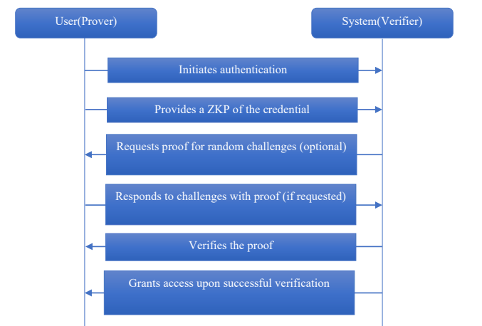
Fig. 2.3.1.1 Zero-Knowledge Proof Sequence Diagram

2.3.2 Feasibility on Resource-Constrained Devices
Whether mobile devices have the computational power that ZKP operations demand is a primary concern in the literature. A 2023 study, "A Survey on Zero-Knowledge Authentication for Internet of Things," tackled the question by comparing various ZKP schemes on hardware constrained in battery and processing power. The survey found that Non-Interactive Zero-Knowledge Proofs (NI-ZKP), and the Groth16 protocol in particular, are highly efficient thanks to their minimal proof size. This confirms that protocols first designed for IoT sensors are computationally feasible on modern smartphones.

2.3.3 Application in Identity and Data Integrity
Zero-knowledge proofs do more than handle logins; they also support richer ways of managing identity. A 2023 study, "Privacy Preserving Identity Management System on Blockchain Using zk-SNARK," showed how zk-SNARKs could run on Ethereum to build decentralized identity systems. People could prove who they are while keeping private details off record. Heavy gas costs, however, slowed transactions as they moved through the network. With those charges piling up, scalability suffered.
In much the same way, a 2025 study titled "A Secure Framework for Privacy-Preserving Analytics in Healthcare Records" applied ZKP to verify sensitive medical data without exposing patient records. It demonstrated the idea of "Auditability without Visibility", showing that a system can confirm a user's authorization status or data validity without ever viewing the underlying sensitive information.

2.4 End-to-End Encryption (E2EE) Protocols

ZKP addresses authentication privacy, but the integrity of the messaging channel itself relies on End-to-End Encryption protocols. The literature is clear on one point: the encryption mathematics are sound, yet the implementation and the surrounding processes remain vulnerable.

2.4.1 Vulnerabilities in Authentication Ceremonies
A major weakness in E2EE systems is the method used to verify that encryption keys belong to the intended user. Alatawi and Saxena (2023), in "SoK: An Analysis of End-to-End Encryption and Authentication Ceremonies," analysed 17 popular messaging applications. They found that "opportunistic" encryption protects against passive eavesdropping but fails against active Man-in-the-Middle (MitM) attacks, because users neglect the manual "Authentication Ceremonies" such as scanning QR codes. Human error in verifying long hexadecimal strings was identified as a critical vulnerability, which suggests that manual verification is functionally broken.

2.4.2 The Insider Threat Landscape
Encryption also creates a "blind spot" for monitoring malicious activity that originates from authorised users. In "Insider Threat Detection and Secure Data Transfer Leveraging Bidirectional LSTM" (2025), researchers proposed Bidirectional Long Short Term Memory (Bi-LSTM) networks to analyse user behaviour patterns. Reading the sequence of actions both forward and backward in time gave higher accuracy for detecting insiders than examining isolated events.
Researchers then turned to a 2024 study titled "A Review of Recent Advances in Malicious Insider Threat Detection." Deep learning copes well with large data sets, yet the review flags real drawbacks. One stands out. The results often lack clear reasoning, since these systems cannot easily reveal what they notice. A second problem appears when parts of a dataset receive very little attention. Genuine insider attacks happen rarely, far less often than everyday network activity. That imbalance makes prediction harder still under real-world conditions.

2.4.3 Architecture and Scalability
The underlying architecture of E2EE systems is itself an active research topic. In "Threat Modeling for Enterprise Secure Messaging Applications" (2025), the authors applied STRIDE threat modelling and found that, even with the network layer encrypted, endpoints stay exposed to metadata analysis and session hijacking. Practical implementation also remains complex. A 2025 study on "Implementation of Secure E2EE Chat Application in Microservice Architecture" built a framework using AES-256 and Diffie-Hellman, but it leaned on standard architectures that ignore post-quantum threats.
Handling growth is not straightforward either. Barnes and his team (2023) note that the security setup for messaging, the MLS Protocol, inherits old patterns from earlier systems such as the Double Ratchet method, where size matters: performance degrades in large groups because the cost scales linearly (O(n)). A newer approach, TreeKEM, builds on a tree-like structure rather than chains. The change cuts the work needed to re-encrypt data down to almost manageable levels (O(log n)). End-to-end crypto, it turns out, need not weaken as activity grows, provided the way it is built keeps pace.

2.5 On-Device AI Anomaly Detection

The last domain in this review concerns detecting the insider threats raised in Section 2.4 without compromising the privacy guarantees of E2EE. Meeting that goal means shifting the analysis away from the cloud and onto the device itself (Edge AI).

2.5.1 The Shift to Edge Computing
In "A Systematic Review of Anomaly detection using Machine and Deep Learning Techniques," Natha et al. (2022) noted that traditional Machine Learning, such as SVM, often underfits complex real-world data and therefore makes Deep Learning necessary. Deep Learning has in turn relied on cloud resources, and that reliance brings privacy risks.
Recent advances have reversed this picture and made on-device detection viable. The paper "PHILDER: Lightweight Framework for Intelligent Phishing Detection on Resource-Limited Devices" (2025) demonstrated a compressed Deep Learning model running on ARM-based mobile processors. Its authors reached over 90% accuracy at detecting threats with less than 100ms latency, proving that heavy cloud servers are not strictly necessary for effective detection.

2.5.2 Mobile Optimization Techniques
Gaurav et al. (2025) reinforce this shift in "AI-Driven Smishing Detection in Android Devices Using TinyBERT." Using a TinyBERT transformer model optimised for Android, they achieved 96.81% accuracy and clearly outperformed traditional models like Random Forest. The result confirms that complex transformer models can be distilled for mobile use.
A 2023 study, "Phishing Detection System Through Hybrid Machine Learning," went a step further by combining algorithms. Its hybrid approach paired "shallow" learning (Random Forest) with "deep" learning features, and this pairing extracted lexical patterns, such as URL length or character randomness, better than any single model on its own.

2.6 Summary and Research Gap

The review of existing literature reveals specific strengths in individual technologies, yet a distinct gap emerges once they must be combined inside SME communication tools.
Summary of Existing Literature:
- Authentication: Checking identities is one such issue, and studies show that basic E2EE checks often collapse (Alatawi & Saxena, 2023). Zero-knowledge proofs help solve this (Bhattacharya et al., 2024), but those methods tend to sit within blockchain or IoT setups rather than the messaging tools people use every day.
- Encryption & Threats: E2EE shields against outside risks, yet firms still lose sight of bad actors already inside. Deep Learning handles the task of spotting such behaviour well, Bi-LSTM methods in particular. The trouble is that nearly all answers depend on analysing traffic across networks, which undoes the private design E2EE was built for.
- Detection: Mobile AI such as TinyBERT or PHILDER works well for certain jobs, spotting SMS scams for example. Few studies, though, look at using similar on-device tools to watch how people behave privately online, right as it happens.

Identified Gap: A missing piece remains: no single approach links Zero-Knowledge Proofs to on-device AI for spotting unusual user behaviour without compromising security. As things stand, picking one means choosing between obscurity and insight. Protecting information hides risks, while lifting restrictions exposes personal details.

2.7 Conclusion
This chapter has critically reviewed the literature on secure messaging, cryptographic authentication, and mobile anomaly detection. One finding stood out. Existing E2EE systems rely too heavily on users confirming identities by hand, which leaves gaps. A second point emerged: Zero Knowledge Proofs could resolve privacy concerns during login, yet few messaging apps actually adopt them. Newer Edge AI tools, somewhat unexpectedly, now let powerful threat analysis run right inside smartphones. The review confirms that the individual technologies needed to secure SME communications already exist, but they lack unified integration. The gaps identified here, namely the absence of automated trust verification and local behavioural monitoring, form the main motivation for this project. These theoretical findings will steer the system design and development approach, detailed in the next chapter, Chapter 3: Methodology.

CHAPTER 3

METHODOLOGY

3.1 Introduction

This chapter sets out the methodology and the steps taken to develop the SentriZK project. Its aim is to describe how a secure messaging tool was built, tested, and launched. It opens by surveying several ways to develop software and explaining why Rapid Application Development stood out as the best fit for this work.
The chapter then works through what happens at each stage of building the system, from collecting user needs to creating early versions of the interface. Rather than merely listing tasks, it looks more closely at how the platform is structured from the bottom up. Several visual artefacts appear: a map of the system components, step-by-step processes, interactive workflows, a guide to navigation paths, and safeguards against likely weaknesses. Each diagram has a purpose in making data protection clear and predictable throughout the experience. The section next covers the equipment and programs needed, the funding involved, and a timeline for the work so that each stage wraps up when expected. Exactly which tools are used during setup also appear here.

3.2 Overview of Software Development Models

Every method of building software carries a way of working that is not always obvious. The model chosen shapes whose voice is heard during planning, how layouts take shape, and when checks happen. This work weighed three paths, Waterfall, Agile, and a faster variant called RAD, to judge which fits best. Each sends development down a different road, and later choices steer the outcome. None behave alike once a project grows.

3.2.1 Waterfall Model
In the early years of software development, this method stood out for being clear and orderly. Rather than looping back or blending stages, it splits the work into fixed blocks: needs are settled first, then mapped into a logical design, and only after that is the code written piece by piece. Testing comes next, with release and then ongoing maintenance whenever problems surface. No stage begins until the one before it is done.
A stage is finished only once formal sign-off has been granted, and work then passes to the next one. Written documentation carries real weight in this approach. Recording the system requirements early fixes them firmly from the very start.
- Strengths: The strict ordering of stages keeps the process simple. Where the requirements are clear and stay settled, the approach works well and with little fuss.
- Weaknesses: the method adapts poorly to change. Once the work has passed the testing phase, reworking anything becomes hard and costly. That rigidity makes it a risky choice when user needs keep shifting. A project whose demands are likely to move may be a poor match for it.
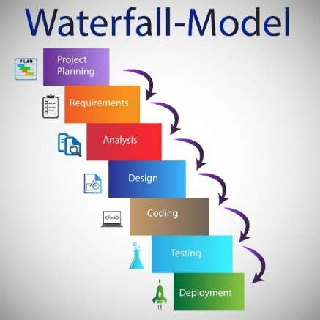

Fig. 3.2.1.1 Diagram Waterfall

3.2.2 Agile Model
Where the traditional Waterfall method runs straight through, the Agile approach starts differently and proceeds in small, repeated steps. Nothing is delivered all at once. The work is divided into short cycles, often termed sprints, making progress easier to track and adjust. Change is frequent because adaptability is built in rather than bolted on. Collaboration counts as much as meeting user needs on time, so little planning is needed upfront.
Change is frequent in Agile because the process learns quickly. Testing is continuous, woven in rather than left to the end. Feedback arrives regularly and reshapes each step once real use shows what works. The result adapts smoothly when conditions turn unpredictable.
- Strengths: Agile is highly flexible and responds well to changing requirements, and its continuous testing helps surface and fix problems at an early stage.
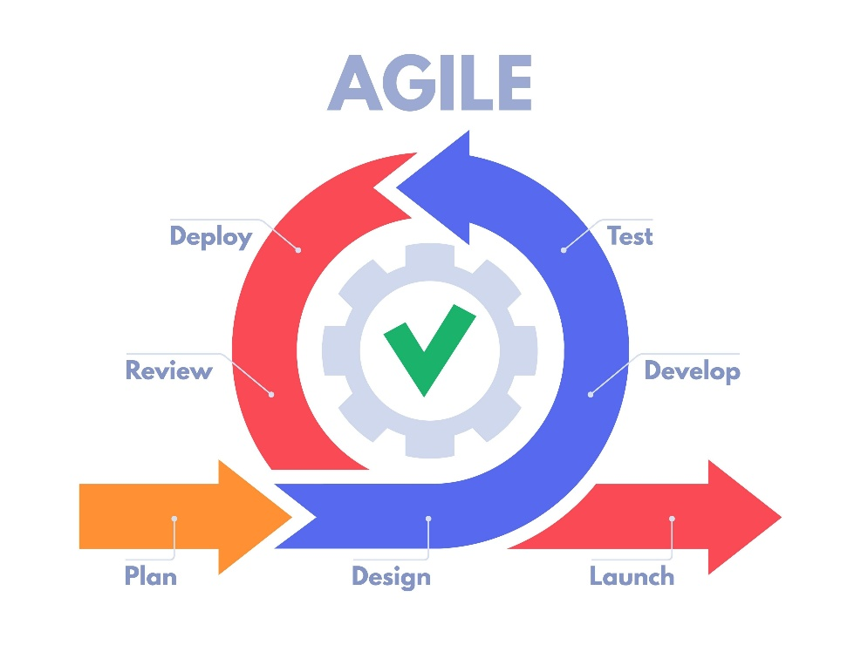
- Weaknesses: Keeping users involved regularly tends to draw a steady amount of effort and staff time. If oversight slips, the project's boundaries can drift beyond what was intended, slowing things down later.
Fig. 3.2.2.1 Diagram Agile Model

3.2.3 Rapid Application Development (RAD)
Rapid application development puts quick prototypes and steady user input at the centre, rather than long-term blueprints. Where conventional methods split work into separate stages, RAD folds analysis, planning, building and checking into rapid loops. Each loop hands over working pieces faster than the traditional sequence would allow.
One feature of RAD is immediately clear: working samples appear fast. These rough versions are shown to users or managers before long. Feedback returns quickly and shapes the changes that keep the work moving forward.
- Strengths: RAD pulls systems together fast, and timelines shrink quickly. Because people get to see the application sooner, it aligns more closely with what users actually need.
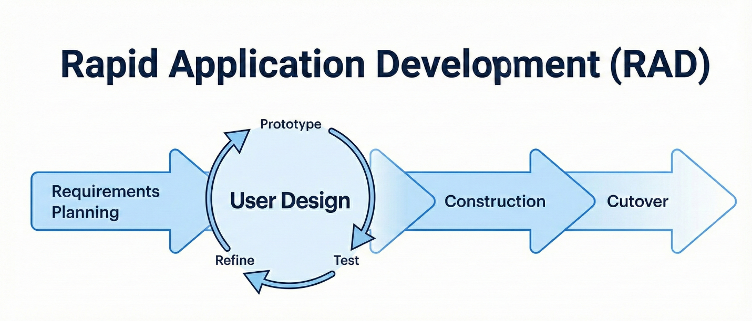
- Weaknesses: A drawback of RAD is its demand that modules be built separately, which is awkward in certain work settings. Yet when deadlines press close, near the end of a student's final semester, its fast pace and early testing loops turn out to be surprisingly useful.

Fig. 3.2.3.1 Diagram Agile Model

3.3 Proposed Methodology

Having weighed several software development approaches, as noted above, the choice settled on Rapid Application Development, chiefly because it suits this project best.
Speed alone was not why we chose RAD. What mattered was the ability to build something and then refine it quickly. Rather than following a fixed sequence of steps, we worked in short repeated cycles of construction. Breaking the work into smaller pieces kept each change manageable. Testing those pieces early fitted naturally, because fresh ideas tended to surface without warning. Where other methods stall once details shift, this one did not. Across the project we moved through stages such as defining needs, sketching layouts, building features, and then cutting over to the new version.

Justification for Choosing RAD
Rapid Application Development (RAD) was chosen chiefly for its focus on early visualisation and iterative prototyping. Pinning down user requirements accurately is often hard in software development. RAD answers this by putting rapid, working mock-ups first, so that stakeholders can interact with early versions of the system. Because this hands-on contact validates both the design and the core features before final implementation, it greatly lowers the chance of misaligned requirements.

The tight time limits of a final year project also call for an efficient development lifecycle. Traditional sequential methods can suffer serious delays when defects surface during late-stage testing. RAD instead speeds development through pre-built components and tasks run in parallel. That faster route matters when a fully working system must be delivered inside a fixed academic timeframe.

A second clear benefit of RAD lies in its flexibility and adaptability. As development proceeds, iterative reviews and feedback often reshape the system requirements. The RAD framework folds such changes smoothly into work that is already under way, without major delays to the project. Here it has a definite edge over stiffer, linear frameworks like the Waterfall model.

The methodology supports effective risk mitigation as well. Splitting the system into smaller, manageable components lets potential vulnerabilities and defects be spotted and dealt with sooner. Testing these modules on their own means localised issues are fixed quickly without holding back the wider development effort, which keeps the risk of large project delays low.

3.4 Phases of Development

SentriZK was built using the Rapid Application Development (RAD) lifecycle. The choice followed from a practical need: the three core modules, namely Zero-Knowledge Authentication, End-to-End Encryption (E2EE), and AI Anomaly Detection, had to be developed in parallel. RAD supports exactly that. Its lifecycle breaks into four phases, which are Requirements Planning, User Design, Construction, and Cutover.

3.4.1 Phase 1: Requirements Planning
The main aim here was to pin down where security, privacy, and intelligence connect to one another.
Data Collection & Scope Definition
- Stakeholder Consultation: Conversations with NISHA SUTERA ENTERPRISE surfaced a clear need: the system must secure login (Auth), protect trade secrets in transit (E2EE), and filter malicious links (ML) on its own, without manual oversight.
- Dataset Acquisition (For ML): Training the Anomaly Detection module called for suitable data. Public datasets of phishing URLs and social engineering text patterns were gathered to train the TensorFlow Lite model.
- Cryptographic Standards Review: The Signal Protocol and ECDH (Elliptic Curve Diffie-Hellman) were analysed so that the E2EE module would meet industry standards, sitting alongside the ZKP implementation.

3.4.2 Phase 2: User Design
During this phase the technical architecture was designed so that all three modules could run together without any loss of performance.

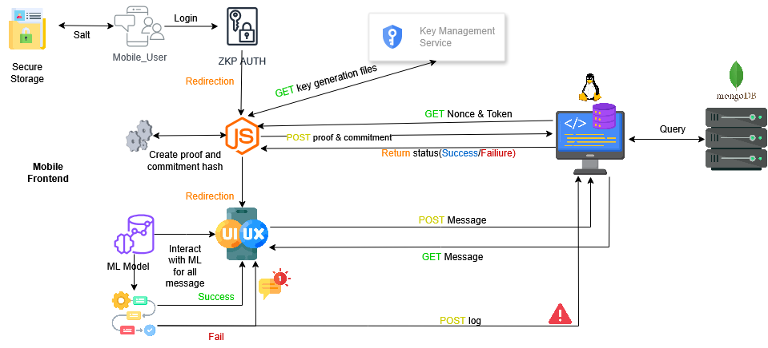
- System Architecture Design: The architecture takes the form of a "Privacy-First" ecosystem. The diagram below sets out the Client-Side processing. It shows the AI Engine placed before the Encryption Layer, so that the server only ever receives opaque, encrypted data.

Fig. 3.4.2.1 SentriZK System Architecture

- Component Interaction Diagrams: Three specific diagrams were drawn to map the core functionalities:
  - ZKP Registration Sequence Diagram: A detailed sequence diagram showing the hybrid mobile-web workflow for secure user registration. It traces how a temporary Mobile Access Token (MAT) is generated, the handoff to a web interface where the computationally intensive ZKP proof is produced, the server-side verification using the Verification Key (VK), and the secure return to the mobile application through deep linking.
  - E2EE Key Exchange Sequence: This diagram sets out the flow of public key exchange and shared secret derivation through ECDH. It shows how ephemeral keys are generated and traded so that messages are fully encrypted before they leave the device, which keeps the server from ever seeing plaintext.

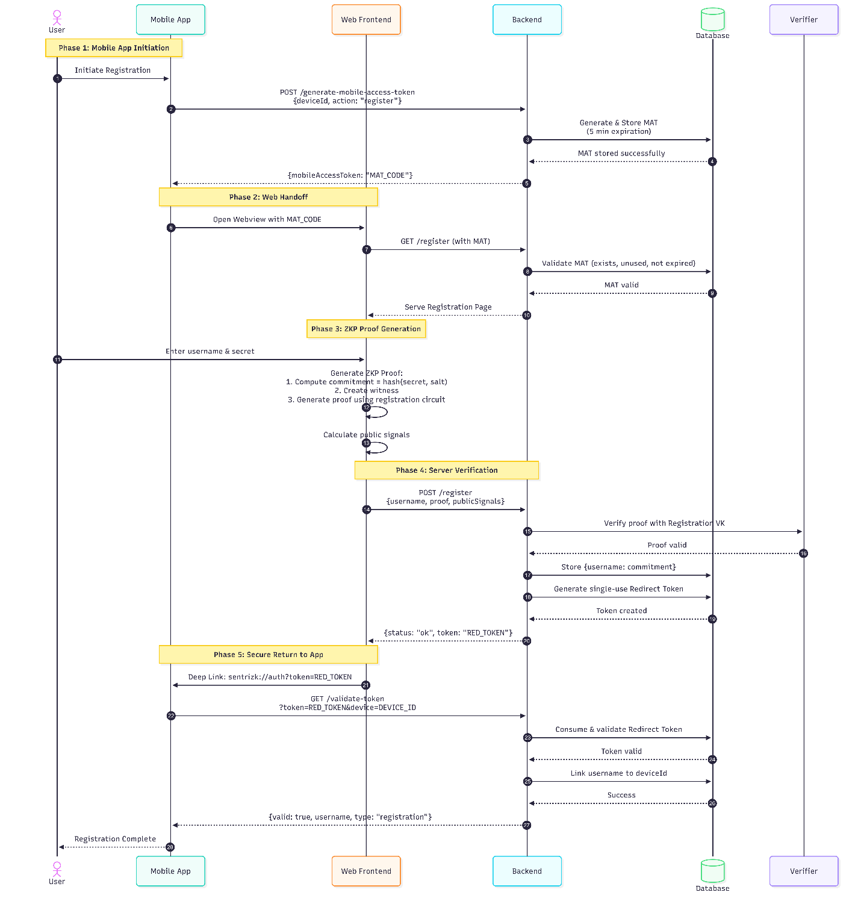

Fig. 3.4.2.2 SentriZK Sequence Diagram

- Process Flowchart: A high-level flowchart was drawn to show the end-to-end operational logic between the Authentication, Sender, and Receiver entities. It sets out the system's decision-making process:
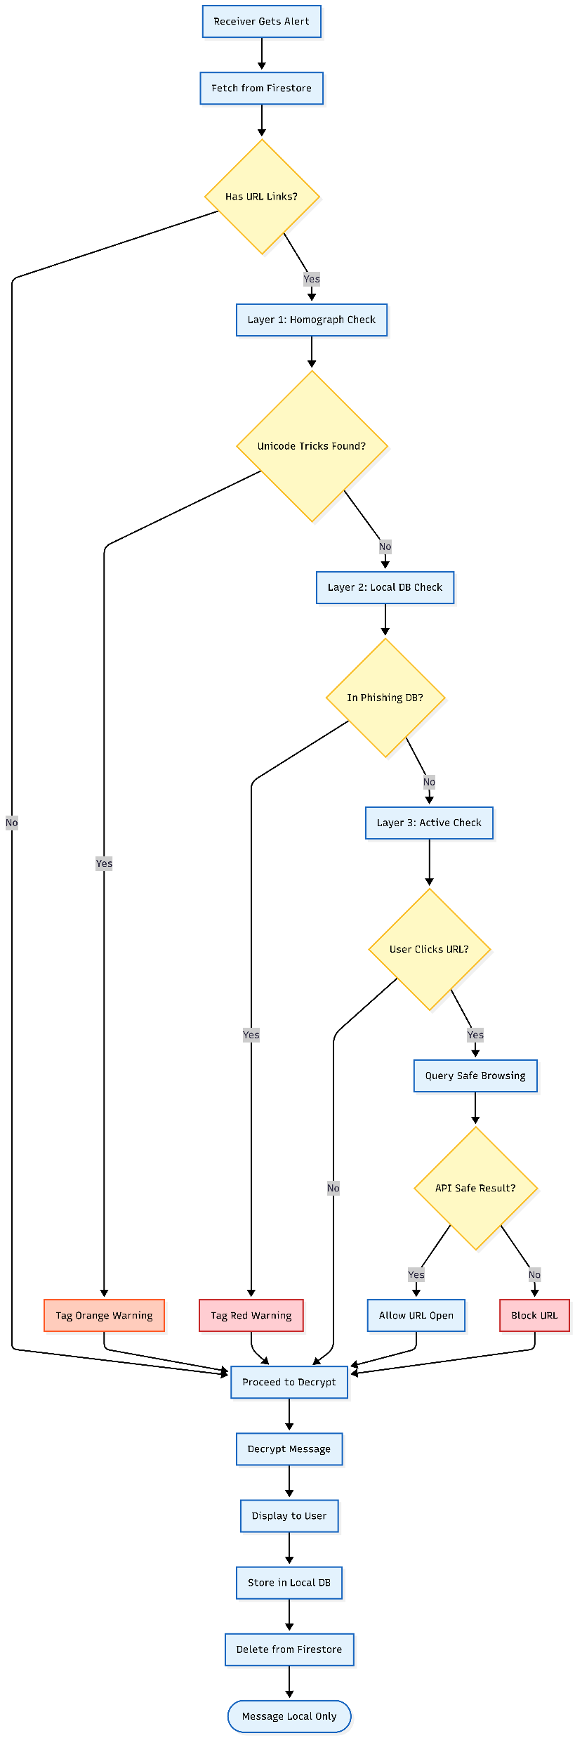
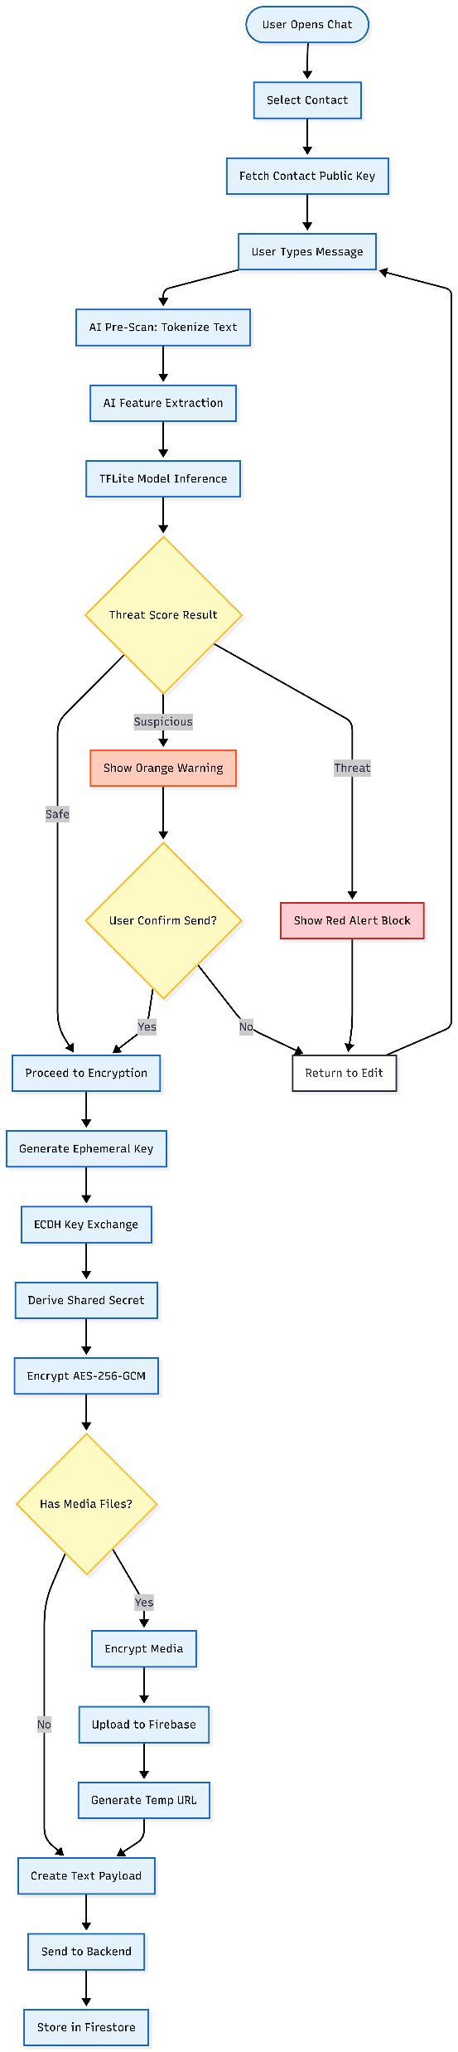
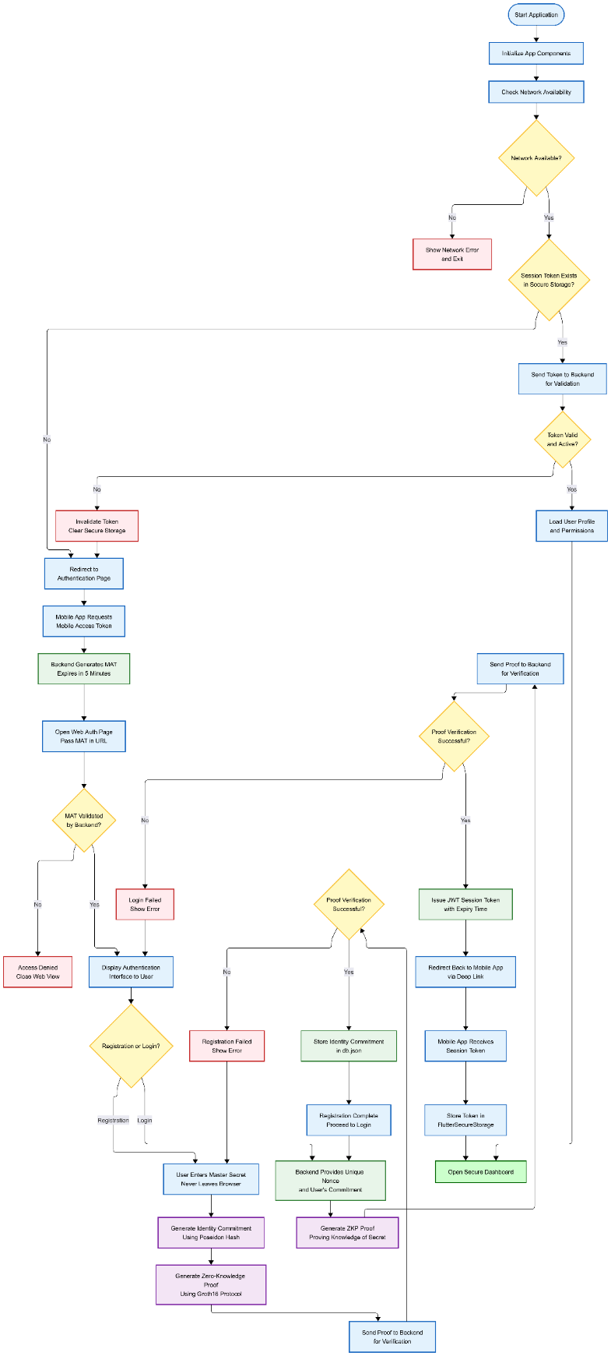

Fig. 3.4.2.3 SentriZK Flow chart
- Use Case Diagram: The Use Case diagram defines the system's functional scope and the interactions of its actors. It names the "SME Employee" as the primary actor and maps how that actor engages with the system's three core security modules

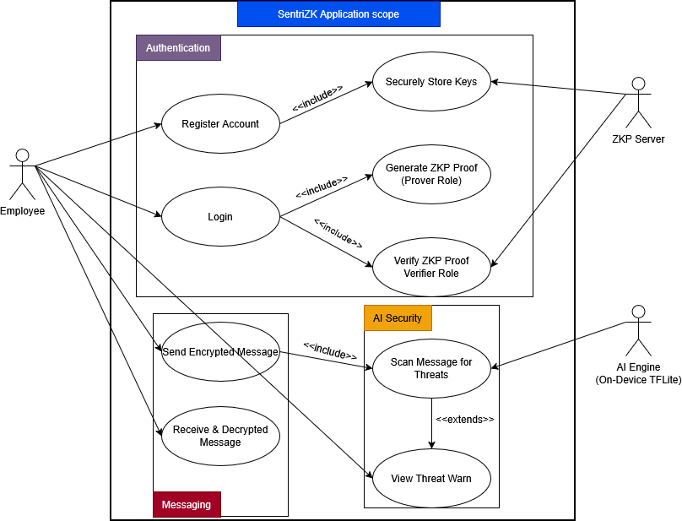

Fig. 3.4.2.4 SentriZK Use Case Diagram

- Threat Model Diagram The threat model was widened to cover vulnerabilities at three critical layers: the Client, the Network, and the Server. The diagram shows the specific attack vectors the system is built to neutralise
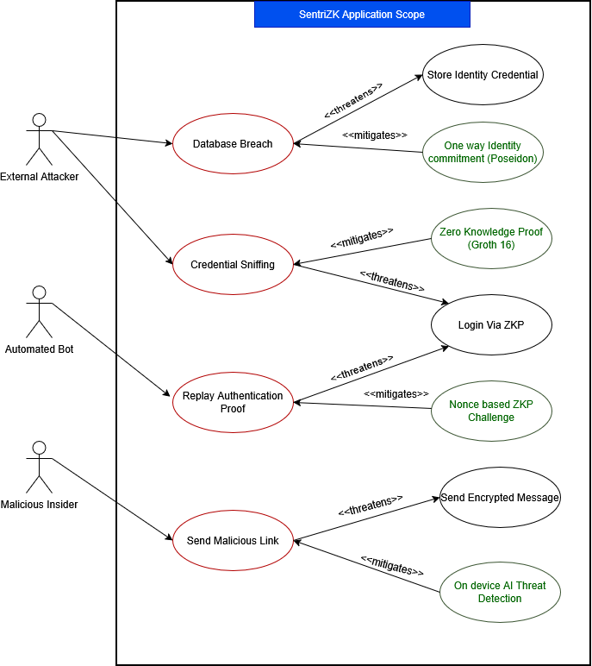
Fig. 3.4.2.5 SentriZK Misuse Case Diagram

3.4.3 Phase 3: Construction
This phase centred on the programming and integration of the system's three core modules. Work was split into separate tasks for authentication, encryption, and threat detection.

Module A: Zero Knowledge Authentication
The authentication module began with writing custom cryptographic circuits in the Circom language. These circuits define the constraints for proving knowledge of a password without revealing it. Once the circuits were designed, a "Trusted Setup" (Powers of Tau) ceremony was run to generate the proving and verification keys that the zk-SNARK protocol needs. The snarkjs library was then integrated into the client application. With this in place, the mobile app could generate mathematical proofs locally, so users verify their identity to the server without ever sending their actual credentials.

Module B: End-to-End Encryption
For the messaging module, the application was programmed to enforce privacy by default. When a user registers, the system automatically generates ephemeral key pairs on the Ed25519 elliptic curve. Message payloads are handled by an AES-256-GCM encryption protocol, implemented with the crypto-js library. The logic works as follows: when User A sends a message to User B, the device first derives a shared secret locally, encrypts the payload, and only then sends the ciphertext to the server. To keep these keys safe, the flutter_secure_storage library stores private keys inside the hardware-backed Android KeyStore or iOS Keychain.

Module C: AI Anomaly Detection
The threat detection module involved training Machine Learning models to spot security risks. An Isolation Forest and an Autoencoder model were trained on gathered datasets that held patterns of social engineering and malicious URLs. After training, the models were optimised and converted to the TensorFlow Lite format, with the file size kept under 10MB for efficient mobile performance. This optimised model was embedded directly into the Flutter client. It intercepts user input in real-time and assigns a "Threat Score" to outgoing messages. Should that score exceed a predefined threshold, the system warns the user before the message is encrypted and sent.

3.4.4 Phase 4: Cutover
The Cutover phase is the final step, where the system moves from a development build to a working prototype ready for demonstration. It is scheduled to begin as soon as the construction phase is finished.

Integration Testing:
At this step the three separate modules, ZKP Authentication, E2EE, and AI, are combined into a single cohesive application. Rigorous testing follows to confirm they work together smoothly. A major focus is verifying that the on-device AI inference runs fast enough. It must not introduce noticeable lag (latency) that would delay the encryption process or make the "Send" button feel unresponsive.

Security Audits:
A thorough security review is planned to validate that the system actually protects data as intended. It draws on a set of specific technical tests:
- Replay Attacks: An attempt will be made to capture an old login proof and send it to the server again, verifying that the system's "nonce" mechanism correctly rejects the duplicate request.
- Simulated Database Breach: The backend database will be accessed directly to confirm that an attacker would find only useless ciphertext and mathematical commitments, proving that no readable user data is stored.
- AI Model Testing: The AI model will be tested against a fresh dataset of phishing links to calculate its detection accuracy and confirm that it provides valid warnings.

User Acceptance Testing (UAT):
The final prototype will be presented to the staff at NISHA SUTERA ENTERPRISE. In a controlled environment, they will be asked to use the system for their standard daily communication tasks. The objective is to confirm that the security measures, and the AI threat warnings in particular, are helpful rather than an intrusion on their daily operational workflow. Feedback gathered from this session will then guide any final adjustments to the interface or sensitivity settings before the project is concluded.

3.5 System Requirements

This section sets out the hardware and software used to build and test the SentriZK system. Because the project is privacy-first by design, the technical setup needed specific tools that could handle cryptographic generation and on-device AI processing, all without depending on external cloud processing.

3.5.1 Hardware Requirements
Hardware was split into high-performance development units and low-cost deployment units, to show that the system is feasible for Small and Medium Enterprises (SMEs).

- Development Workstation (Lenovo Legion)
The primary development phase called for a high-specification laptop. A dedicated GPU mattered here because training the Isolation Forest AI models is computationally demanding. Running the Android Studio emulator alongside the Node.js backend also pushed up the requirement, needing a minimum of 16GB RAM to keep the testing environment stable.
- Mobile Test Device (Physical Android Phone)
Emulators handled the early interface design, but a physical Android device was needed for final system verification. Only real hardware could accurately test camera performance for scanning ZKP QR codes and gauge the biometric authentication sensors. Testing on a physical device also gave critical data on battery consumption and heat generation while the AI inference process ran.
- Server Node (Raspberry Pi 5 - 8GB)
To sidestep the recurring costs of cloud hosting services such as AWS, a Raspberry Pi 5 served as the primary server. It hosts the backend API and the database. The 8GB RAM model was chosen so there was enough memory to handle concurrent verification requests, which shows that the whole security architecture can run on accessible, low-cost hardware.

3.5.2 Software Requirements
The software stack is built from open-source tools, picked for their security features and mobile compatibility.

- Flutter: This framework was chosen for mobile development on grounds of efficiency. A single codebase could then run across various Android versions, with no need for extensive native code adjustments.
- GetX: This library handled state management, simplifying how data flows between the secure login screens and the encrypted chat interface.
- Next.js: A web-based interface was built with Next.js to take on the computationally intensive ZKP key generation, a process that can be heavy for older mobile devices.
- Node.js: The backend logic runs on the Node.js runtime. I chose it for its lightweight architecture and its efficient handling of the JSON data packets sent from the mobile client.
- Cloudflare Tunnel: Exposing the local Raspberry Pi server through router port forwarding is risky, so Cloudflare Tunnel was used instead. The service opens a secure, encrypted connection to the internet for external access.
- Firebase: This service is used strictly for "signaling" purposes, notifying a user that a message is waiting without ever storing the actual message content.
- TensorFlow Lite: The original Machine Learning models were converted into the TensorFlow Lite format. This optimisation cut the file size and let the Isolation Forest model run locally on the device for real-time threat detection.
- SnarkJS: This JavaScript library is integral to the system. It handles the mathematical generation of Zero-Knowledge Proofs on the client side and their verification on the server side.
- Hive DB: For local storage, Hive DB was used because its read/write speeds beat those of traditional SQL databases, which keeps access to the encrypted chat history quick.

3.5.3 Budget and Costing
The primary objective of this project was to demonstrate a cost-effective security solution for SMEs. The self-hosted architecture met that aim, eliminating most recurring monthly subscription costs.
The table below splits the financial resources into "Assets" (equipment already owned and reused for the project) and "Expenditure" (the funds actually spent).
Item | Category | Cost (RM) | Description
Development Hardware
Lenovo Legion Laptop | Asset | 4,500.00 | Existing workstation used for coding and training.
Android Test Phone | Asset | 800.00 | Physical devices are used for hardware-level testing.
Server Infrastructure
Raspberry Pi 5 (8GB) | Asset | 400.00 | Self-hosted server node to eliminate cloud fees.
Software & Services
Cloudflare Tunnel | Service | 0.00 | Free Tier (Zero Trust) for secure remote access.
Firebase (Spark Plan) | Service | 0.00 | Free Tier is utilized for signaling only.
Project Expenditure
Domain Name (.com) | Cash Out | 80.00 | 1 year registration fee for the web identity.
TOTAL COST |  | RM 80.00 | Total actual cash expenditure.

Table 3.5.3.1: Project Cost Breakdown

3.6 Project Planning

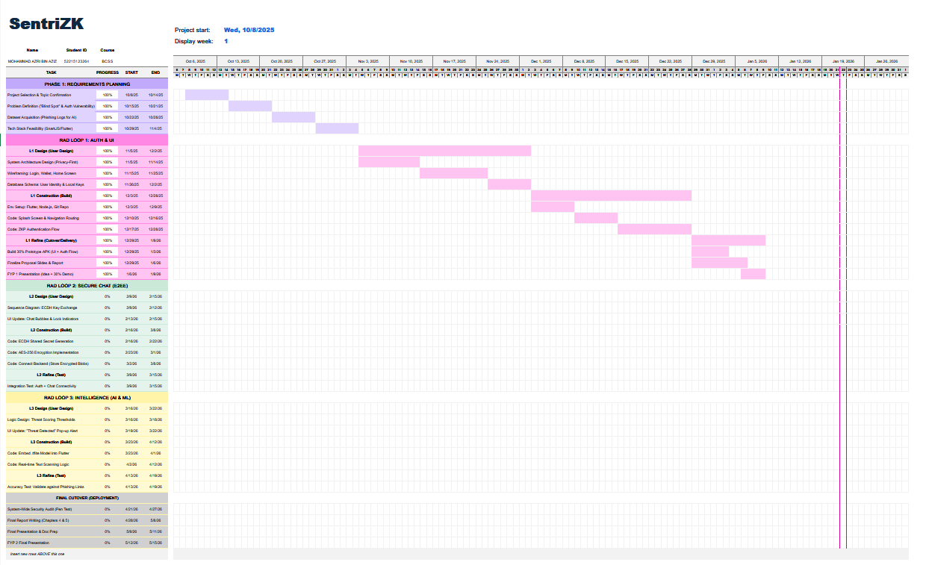
Gantt Chart Link: Excel_File_Link
Figure 3.6.1: Project Gantt Chart Summary

3.7 Chapter Summary
This chapter explained the methodology and the tools chosen to develop the SentriZK project. The Rapid Application Development (RAD) model was selected because the three main security modules can be built and tested in cycles, rather than waiting for one massive phase to finish. The technical design was then mapped out through specific diagrams, including the system architecture and the threat model, which give a clear picture of how the "Privacy First" logic actually works.
This chapter also set out the hardware and software the project needs, and showed that it can run on a tight budget with self-hosted tools such as the Raspberry Pi. With the design and planning now settled, what remains is to build the system itself. The next chapter, Chapter 4: System Development, will document the practical steps taken to write the cryptographic code, train the AI models, and bring everything together inside the mobile application.

CHAPTER 4

SYSTEM DEVELOPMENT

4.1 Introduction
This chapter documents how the SentriZK secure messaging system was built in practice, turning the architecture and design from Chapter 3 into a working software product. Chapter 3 set out the intended methodology and the high-level design. The focus here shifts to what was actually engineered: the tools and frameworks used, and the technical decisions taken during construction. The account follows the Rapid Application Development (RAD) lifecycle adopted for this project, under which the three core security modules Zero-Knowledge Proof (ZKP) authentication, end-to-end encrypted (E2EE) messaging, and on-device Artificial Intelligence (AI) threat detection were built and refined in overlapping increments.
The chapter opens by defining the development environment, frameworks, and software dependencies of each component. It then walks through the installation, setup, and configuration of the backend server, the cryptographic circuits, the web portal, the mobile application, and the machine-learning pipeline. Each of the three security modules is described in detail. From there the discussion turns to the user-interface and experience design, the system integration that binds the components together, the source-code management and version evolution of the project, and the deployment environment. Several implementation choices grew beyond the original proposal as the prototype matured. These deviations are flagged and justified as informed engineering decisions at the relevant points in this chapter.

4.2 Development Environment and Tools
SentriZK lives in a single Git monorepository made up of four cooperating sub-projects: a Node.js backend, a Next.js web portal, a Flutter mobile application, and a Python machine-learning pipeline. This section sets out the hardware, the operating systems, the integrated development environments (IDEs), and the languages, runtimes, and full set of third-party dependencies used to build it.

4.2.1 Hardware and Operating System
Most development took place on a Windows 11 workstation, a Lenovo Legion laptop with a dedicated GPU and 16 GB of RAM. The GPU sped up training of the neural-network threat-detection models. With 16 GB of memory, the Android emulator, the Node.js backend, and the Next.js development server could all run at once. For final checks a physical Android device was used (minimum Android 10, API level 29), covering camera access, biometric prompts, push notifications, deep-link handling, and on-device model inference. None of these can be judged reliably on an emulator. The development and test hardware is summarised in Table 4.1.
Table 4.1: Development and Test Hardware
Unit | Role | Key Specification
Lenovo Legion laptop | Primary development & ML training | Windows 11, dedicated GPU, 16 GB RAM
Physical Android phone | On-device verification | Android 10+ (API 29+), real sensors
Server node | Backend / database host | Self-hosted Linux node, 8 GB RAM

4.2.2 Integrated Development Environments and Tooling
Visual Studio Code served as the main IDE for the backend, web, and machine-learning code. Android Studio supplied the Android SDK, the emulator, and the Gradle build toolchain that the Flutter application needs. Version control ran on Git throughout, with the remote repository hosted on GitHub. Several command-line tools supported this work: the Node.js package manager (npm), the Flutter and Dart command-line tools, the Circom compiler and the snarkjs toolchain for the zero-knowledge circuits, and ngrok, which exposed the local backend to mobile devices during testing.

4.2.3 Frameworks, Languages and Runtimes
The system is polyglot out of necessity, since each tier has its own performance and ecosystem demands. The backend is written in JavaScript on the Node.js runtime (version 18 or higher) with the Express 5 web framework. For the web portal, the language is TypeScript, built on Next.js 15.5.6 with React 19. The mobile application uses Dart (SDK 3.8) on the Flutter framework. Zero-knowledge circuits are expressed in the Circom 2.0.0 domain-specific language and proven with the Groth16 zk-SNARK system over the BN128 elliptic curve. The machine-learning pipeline is written in Python with TensorFlow 2.20 and Keras 3.13. Table 4.2 lists the core framework of each tier.
Table 4.2: Core Framework of Each System Tier
Tier | Language | Framework / Runtime
Backend API | JavaScript | Node.js 18+, Express 5.1
Web portal | TypeScript 5 | Next.js 15.5.6, React 19.1
Mobile app | Dart 3.8 | Flutter 3.8
ZK circuits | Circom 2.0.0 | Groth16 / BN128 (snarkjs 0.7.5)
ML pipeline | Python | TensorFlow 2.20, Keras 3.13

4.2.4 Software Dependencies
Each sub-project draws on a curated set of open-source libraries. On the backend these are snarkjs for Groth16 proof verification, circomlibjs for the Poseidon hash function, the Supabase client for PostgreSQL access, the Firebase Admin SDK for push notifications and custom-token issuance, and a group of standard security middleware (express-rate-limit, jsonwebtoken, bcryptjs, cors). Table 4.3 lists the principal backend dependencies.
Table 4.3: Principal Backend Dependencies
Package | Version | Purpose
express | 5.1.0 | HTTP/REST framework (port 6000)
snarkjs | 0.7.5 | Groth16 zk-SNARK proof verification
circomlibjs | 0.1.7 | Poseidon hash / BN128 field arithmetic
@supabase/supabase-js | 2.101.1 | Supabase PostgreSQL client
firebase-admin | 13.0.0 | FCM push, Firestore admin, custom tokens
express-rate-limit | 8.1.0 | Brute-force / rate-limit protection
jsonwebtoken | 9.0.3 | Admin session JWT (HS256)
bcryptjs | 3.0.3 | Admin password hashing

To generate zero-knowledge proofs inside the browser, the web portal depends on snarkjs and circomlibjs. It also uses bip39 for recovery-phrase generation, js-sha3 for username hashing, crypto-js for client-side salt encryption, and axios for talking to the backend. The principal web dependencies appear in Table 4.4.

Table 4.4: Principal Web Portal Dependencies
Package | Version | Purpose
next / react | 15.5.6 / 19.1.0 | Web application framework
snarkjs | 0.7.5 | In-browser Groth16 proof generation
circomlibjs | 0.1.7 | Poseidon / field arithmetic
bip39 | 3.1.0 | 24-word recovery mnemonic
js-sha3 | 0.9.3 | SHA3-256 username / address hashing
crypto-js | 4.2.0 | AES salt-envelope encryption (browser)
axios | 1.12.2 | REST calls to the backend

Of all the tiers, the mobile application has the largest dependency surface, since it hosts messaging, encryption, on-device inference, calling, and notifications. Table 4.5 lists its most significant dependencies. Two choices here depart from the original proposal and are taken up further in the relevant sections: message encryption uses the Signal Protocol implementation libsignal_protocol_dart rather than a bespoke scheme, and local storage uses the Isar embedded database in place of Hive. For state management, the lightweight provider package was chosen over GetX.

Table 4.5: Principal Mobile Application Dependencies
Package | Version | Purpose
libsignal_protocol_dart | 0.7.2 | Signal Protocol (X3DH + Double Ratchet) E2EE
tflite_flutter | 0.12.0 | On-device TensorFlow Lite inference
isar / isar_flutter_libs | 3.1.0 | Embedded reactive NoSQL database
flutter_secure_storage | 10.0.0 | Android Keystore / iOS Keychain storage
provider | 6.1.5 | State management (ChangeNotifier)
app_links / url_launcher | 7.0.0 / 6.3.2 | Deep-link bridge to the web portal
cloud_firestore / firebase_messaging | latest | Ciphertext relay and FCM push
flutter_webrtc | 0.12.1 | Audio / video calling (DTLS-SRTP)
cryptography | 2.5.0 | AES-256-GCM recovery-salt envelope

For the machine-learning pipeline, TensorFlow and Keras handle model construction and TensorFlow Lite conversion, scikit-learn the train/validation split and evaluation metrics, and pandas and numpy the data handling. The evaluation charts were produced with matplotlib and seaborn. A CUDA-enabled build of PyTorch also formed part of the training environment and was used during experimentation.

4.3 System Architecture as Implemented
As built, the system splits into four tiers that work together across the network. Employees rely on the Flutter mobile application as their main client for messaging and calling. The heavy zero-knowledge proof generation, which a phone cannot run efficiently, is offloaded to a Next.js web portal that serves as a dedicated cryptographic surface. Proof verification, session management, and notification brokering all sit in a Node.js/Express backend. Storage is divided between a Supabase PostgreSQL database, which holds authentication state, and Firebase Firestore, which relays encrypted messages and drives the real-time features. The complete implemented architecture appears in Figure 4.1.
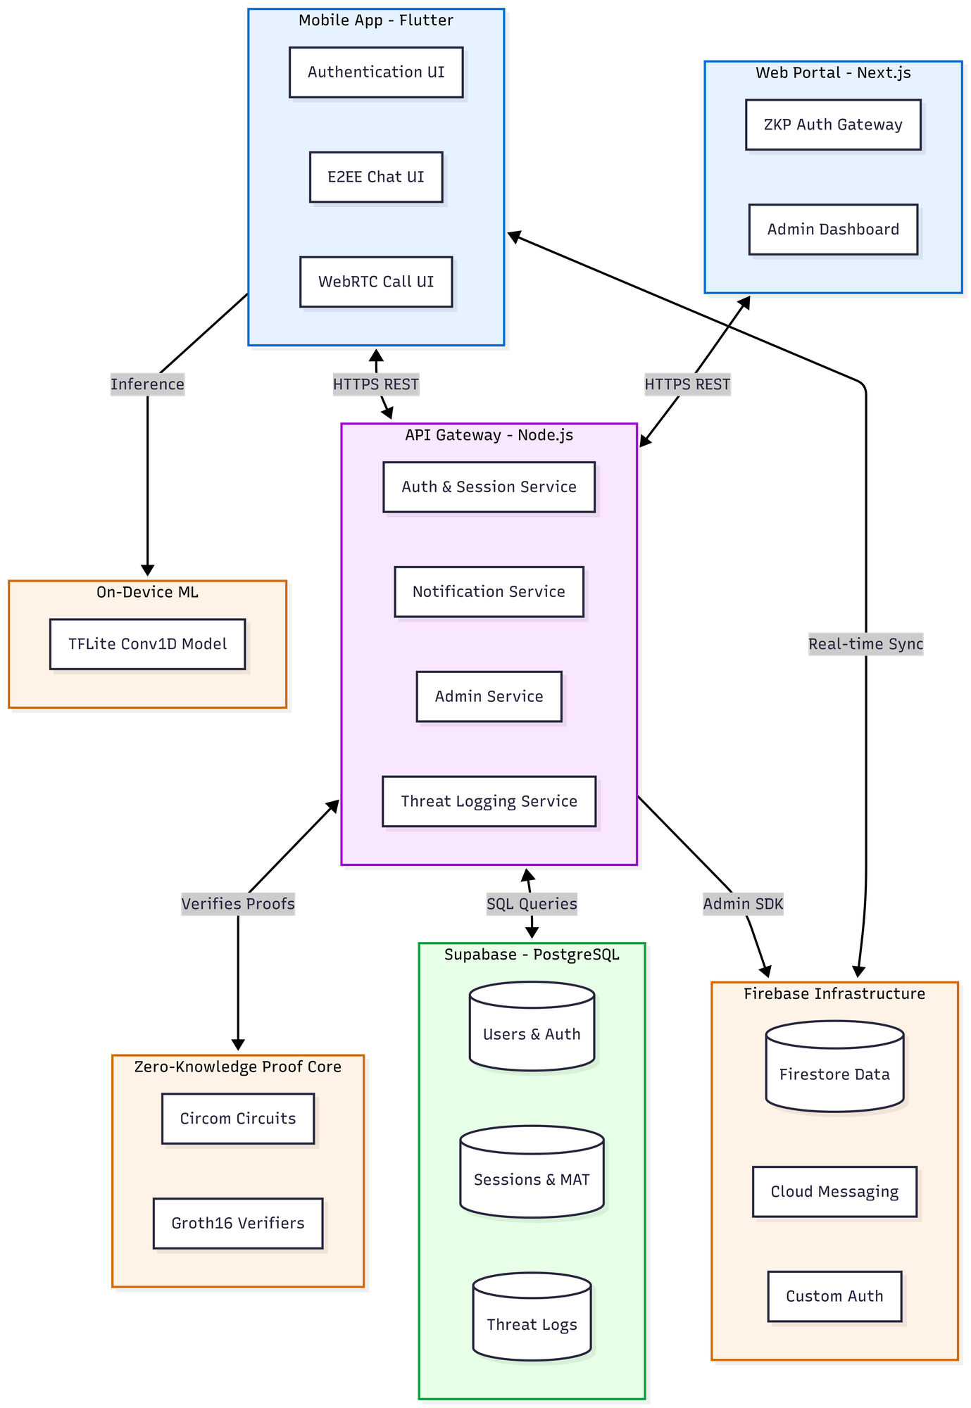
Figure 4.1: SentriZK Full System Architecture (as implemented)

One principle shapes the whole design: the server never keeps anything an attacker would find worth stealing. Rather than passwords, the backend holds only Poseidon commitments, and the messaging tier keeps Signal Protocol ciphertext rather than plaintext. The internal structure of the mobile client — its services for authentication, messaging, encryption, scanning, and notifications is shown in Figure 4.2.

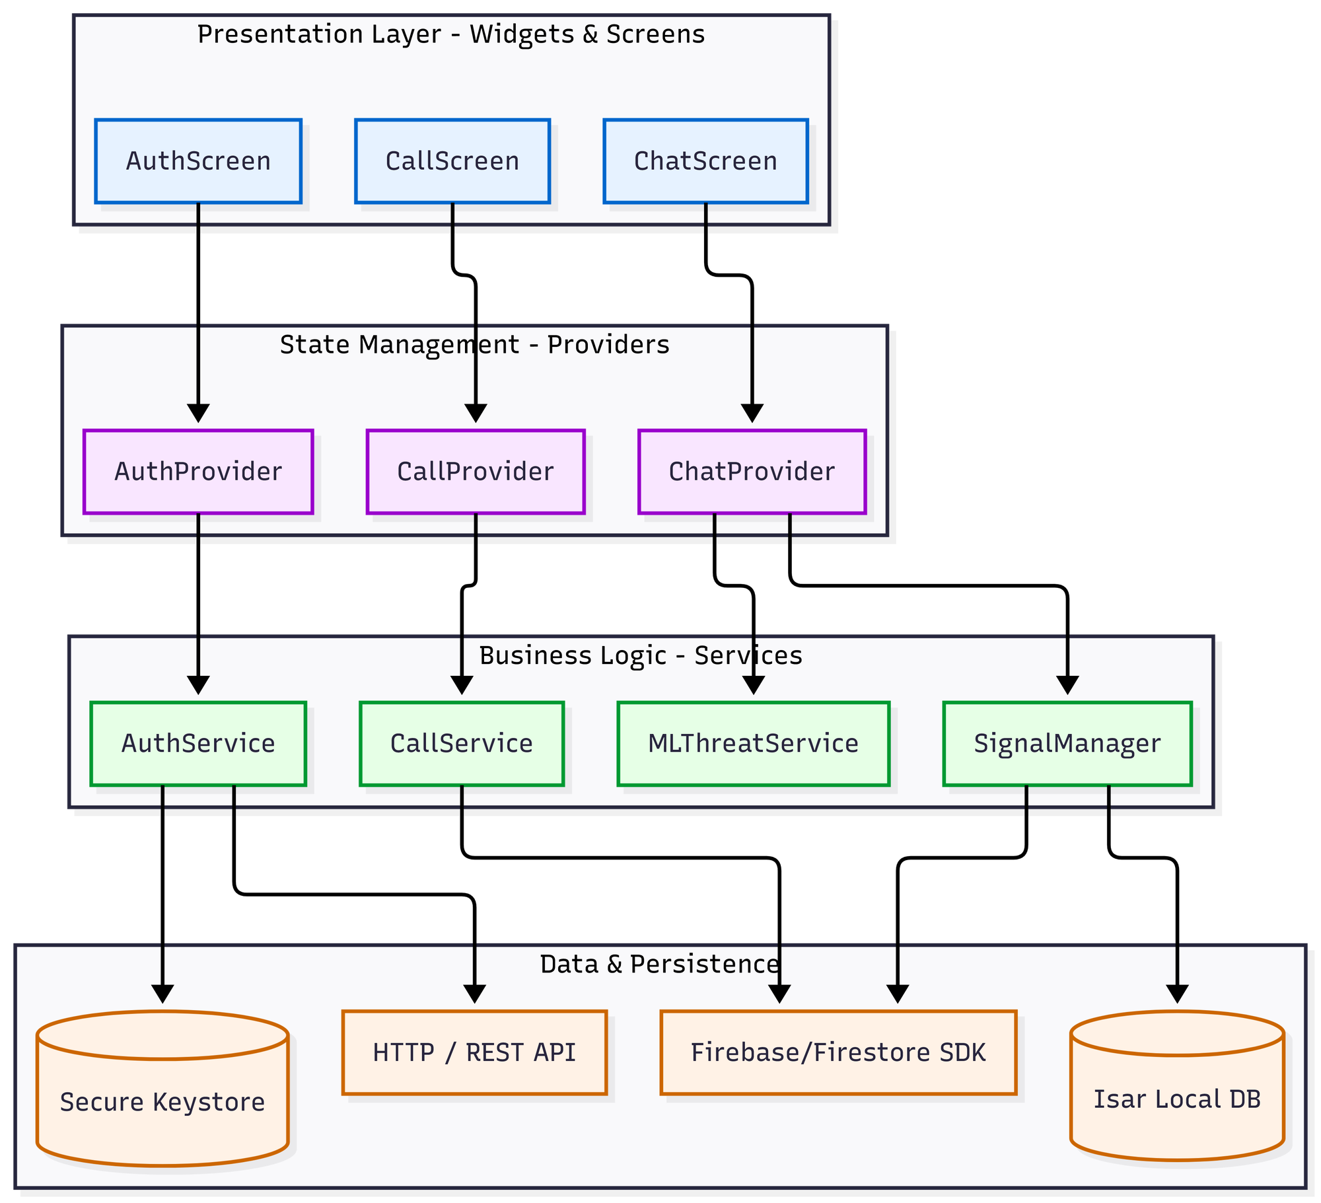
Figure 4.2: Component Diagram of the Flutter Mobile Application

4.4 Installation, Setup and Configuration
This section sets out how each component is installed and configured. Configuration is centralised, which keeps environment-specific values such as service URLs, database credentials, and cryptographic artefact paths out of the source code. The backend and test tooling read their configuration from .env files. The web portal reads public configuration from NEXT_PUBLIC_ environment variables. For the mobile application, endpoints come from a single app_config.dart file with an optional .env override.

4.4.1 Backend Server Setup
The backend is installed with npm install inside the Backend directory, and the server starts with node server.js. It then listens on port 6000 and binds to all interfaces. A few pieces of configuration must be in place beforehand. A .env file supplies the Supabase URL and service-role key, the administrator credentials, and the JWT signing secret; if any of these are missing, the server deliberately refuses to start. A Firebase service-account key file is also required so the Admin SDK can issue custom tokens and send push notifications. Both zero-knowledge verification keys must exist on disk, and the Poseidon hash function is built once at start-up. Until it is ready, endpoints that rely on it return a temporary unavailable status. Last, the Supabase schema script is applied to create the five database tables and their indexes.
Table 4.6: Backend Environment Configuration
Variable | Purpose
SUPABASE_URL / SUPABASE_SERVICE_ROLE_KEY | PostgreSQL connection (required)
ADMIN_USERNAME / ADMIN_PASSWORD | Admin dashboard credentials
JWT_SECRET / JWT_TTL | Admin JWT signing key and lifetime (default 1h)
PORT | Listening port (default 6000)
serviceAccountKey.json | Firebase Admin SDK private key (file)

4.4.2 Zero-Knowledge Circuit Compilation and Trusted Setup
The Circom 2.0.0 compiler turns the two Circom circuits into a WebAssembly witness generator and an R1CS constraint system. A Groth16 trusted setup follows, carried out with snarkjs. A Powers-of-Tau phase produces the universal parameters; a circuit-specific phase-two contribution produces the proving key, stored as a .zkey file; and the verification key is exported as JSON. The proving keys and WebAssembly witness generators are copied into the web portal, allowing proofs to be generated in the browser, and the backend loads the verification keys. The compiled artefacts stay compact. The registration witness generator is approximately 1.84 MB with a proving key of approximately 459 KB, whereas the login witness generator is approximately 2.17 MB with a proving key of approximately 740 KB.

4.4.3 Web Portal Setup
For the web portal, npm install is run inside the Frontend/web directory. Development uses npm run dev, while production is built with npm run build, both relying on the Turbopack bundler. Its configuration comes down to the backend API URL and the four paths to the circuit artefacts, namely the login and registration WebAssembly and proving-key files, which are served as static assets from the public directory. No secret values live in the web tier. All sensitive cryptographic material is derived transiently on the client and is never persisted.

4.4.4 Mobile Application Setup
The mobile application is installed with flutter pub get inside the Frontend/mobile directory. It then runs with flutter run on a connected device, or it is built for release with flutter build apk. A single app_config.dart file holds its endpoints, pointing the application at the backend API and the web portal. The same file defines the custom deep-link scheme, the session and token lifetimes, and the machine-learning thresholds. Firebase is set up through the standard google-services.json file, and an optional .env file supplies the Google Safe Browsing API key.

4.4.5 Machine-Learning Pipeline Setup
The machine-learning pipeline forms a self-contained Python project. Once the dependencies are installed, a single training script runs to read the prepared dataset, train the models, convert the mobile model to TensorFlow Lite, and export the vocabulary file. The two output artefacts, the quantised model and its vocabulary, are then copied into the mobile application's asset bundle and loaded from there at runtime.

4.5 Implementation of the Core Security Modules
Construction focused on three modules that, together, meet the project's objectives: zero-knowledge authentication, end-to-end encrypted messaging, and on-device AI threat detection. Each is described below in terms of what was built and the specific techniques behind it. Where the implementation departed from the original proposal, the discussion also explains how and why.

4.5.1 Module A: Zero-Knowledge Proof Authentication
The authentication module replaces password transmission with a zero-knowledge proof of knowledge. Two Circom 2.0.0 circuits were written for this purpose. The registration circuit computes a single Poseidon commitment from the user's secret, a salt, and a hash of the username; the secret is range-checked to 256 bits and the salt to 128 bits. The login circuit recomputes that commitment from the same private inputs, asserts that it matches the commitment stored on the server, and outputs a Poseidon session value that binds the proof to a fresh server-issued nonce. The two circuits compile to 991 and 1,573 rank-one constraints respectively, which confirms that the proofs are small enough to generate and verify quickly. Table 4.7 summarises the circuit parameters.

Table 4.7: Zero-Knowledge Circuit Parameters
Property | Registration circuit | Login circuit
Commitment | Poseidon(secret, salt, unameHash) | recomputed and asserted equal
Private inputs | secret (256-bit), salt (128-bit) | secret, salt
Public inputs | unameHash | unameHash, storedCommitment, nonce (64-bit)
Outputs | commitment | pubCommitment, pubSession
R1CS constraints | 991 | 1,573
Proving system | Groth16 / BN128 | Groth16 / BN128

A practical constraint shaped the most significant design decision in this module. Groth16 proof generation relies on the snarkjs WebAssembly prover, which a Flutter application cannot run efficiently on-device. Rather than weaken the cryptography, the implementation delegates proof generation to the web portal through a short-lived Mobile Access Token (MAT). When the user begins registration or login, the mobile application requests a single-use, device-bound MAT valid for five minutes, then opens the system browser to the web portal carrying that token. The browser handles the heavy proof generation and submits the proof to the backend, and the result returns to the application through a custom sentriapp:// deep link. This bridge keeps every secret on the user's own devices while shifting only the computational burden to the browser. Figure 4.3 and Figure 4.4 show the registration and login sequences.
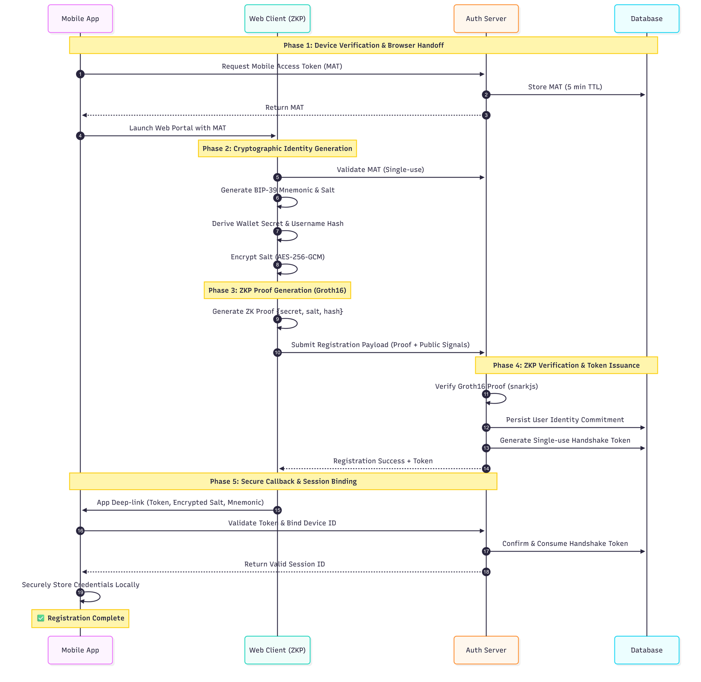
Figure 4.3: Zero-Knowledge Registration Flow
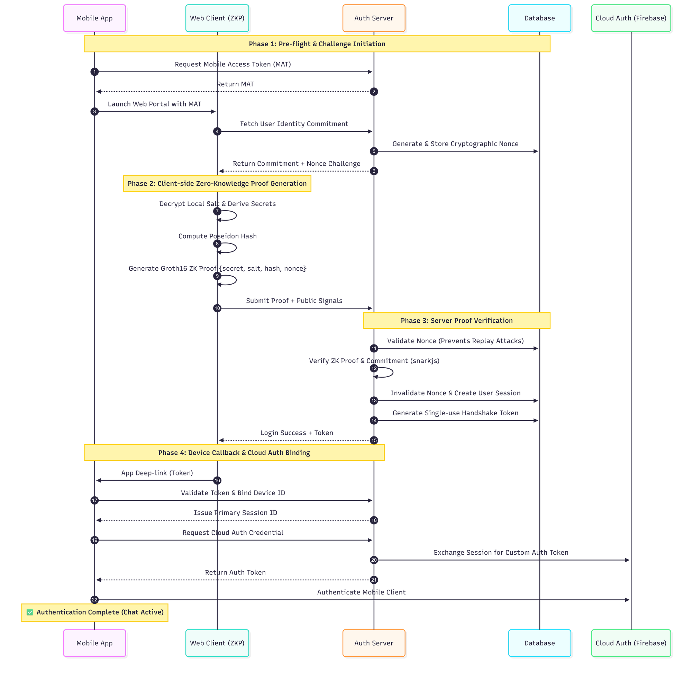
Figure 4.4: Zero-Knowledge Login Flow with Nonce-Bound Session

The cryptographic inputs are derived entirely on the client. The secret comes from the user's wallet address using SHA3-256 and is never stored, being re-derived on each login. The salt is derived from a 24-word BIP-39 recovery phrase using HKDF-SHA256, and it is stored on the device only as an AES-256-GCM envelope whose key is derived from the user's password using PBKDF2-HMAC-SHA256 with 310,000 iterations. The username hash is computed with SHA3-256 and reduced to a field element. Since the server receives only the Poseidon commitment and the proof, a breach of its database yields no passwords, secrets, or salts.
Replay protection is built into the login circuit. For each login attempt the server issues a fresh 64-bit nonce with a 60-second lifetime, and the circuit binds that nonce into the session output, so a captured proof cannot be replayed against a different nonce. After a successful login the nonce is consumed, a 30-minute session is created, and a single-use redirect token is issued. The session is bound to the device identifier and rotated on every refresh to resist session-replay attacks.

4.5.2 Module B: End-to-End Encrypted Messaging
For message confidentiality the implementation adopts the Signal Protocol through the libsignal_protocol_dart library, rather than the bespoke Ed25519-and-AES scheme sketched in the proposal. The choice was deliberate. Hand-rolled cryptographic protocols are notoriously error-prone, whereas the Signal Protocol is a peer-reviewed, widely deployed standard that provides forward secrecy and post-compromise security out of the box. Adopting it strengthened the security guarantees of the system and at the same time reduced the risk of implementation flaws.

Under this protocol each device generates a long-term identity key pair, one signed pre-key, and one hundred one-time pre-keys, all on the Curve25519 elliptic curve. Only the public half of this bundle is published, to the user's Firestore document, so that other users can start a session without any prior contact. When a message is sent, the application fetches the recipient's public bundle, establishes a shared secret using the Extended Triple Diffie-Hellman (X3DH) handshake, and encrypts the message with the Double Ratchet algorithm. That algorithm rotates the message key for every single message, which provides per-message forward secrecy. The resulting ciphertext is relayed through Firestore; the server never sees plaintext or private keys. Figure 4.5 shows the complete messaging flow.
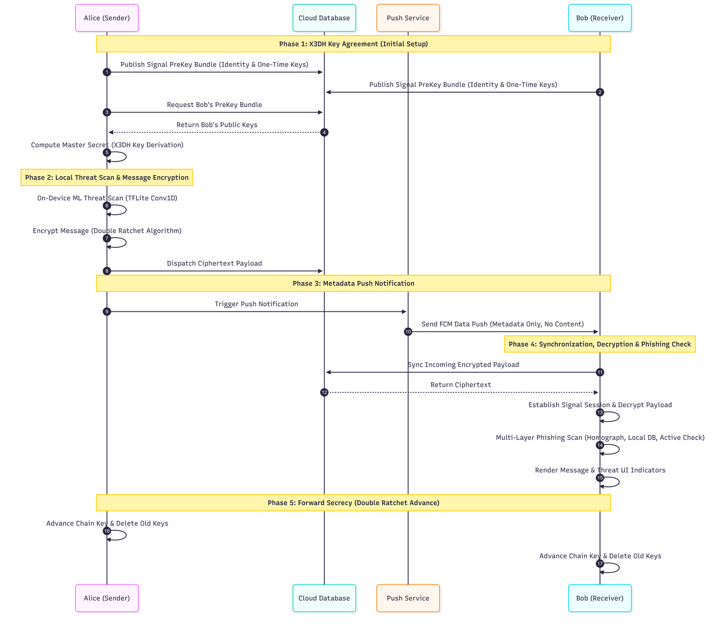
Figure 4.5: Signal Protocol End-to-End Encrypted Messaging

The application also implements an offline-first storage model. Incoming ciphertext is decrypted, written to a local Isar database, and then removed from Firestore, so the device becomes the durable source of truth for conversation history while the cloud retains as little as possible. Audio and video calls use a separate WebRTC channel secured by DTLS-SRTP, with Firestore handling only call signalling. Account-recovery material is protected by the AES-256-GCM salt envelope described in the previous section.

4.5.3 Module C: On-Device AI Threat Detection
The threat-detection module analyses message content for social-engineering and phishing indicators entirely on the device, so no message text is sent to a server for scoring. During development, the unsupervised Isolation-Forest and Autoencoder approach named in the proposal proved poorly matched to the task: a labelled corpus of safe and malicious messages was available, which makes the problem naturally a supervised binary classification. The module was therefore built around two supervised neural networks trained on the same dataset. A Bidirectional Long Short-Term Memory (Bi-LSTM) network served as a high-accuracy research model on the workstation, and a one-dimensional Convolutional Neural Network (Conv1D) served as the production model on the mobile device. The Conv1D model was chosen for deployment because every one of its operations is natively supported by TensorFlow Lite, letting it run on the phone's hardware accelerators without a compatibility delegate.

The model was trained on a balanced dataset of 5,740 labelled messages, split into 2,890 safe and 2,850 threat examples. These were aggregated from the Enron corporate-email corpus, the ExAIS SMS spam collection, the Jigsaw multilingual toxic-comment dataset, and a set of hand-crafted synthetic insider-threat and phishing messages. Each message is tokenised against a 10,000-word vocabulary and padded to a fixed length of 120 tokens. The production network stacks a 64-dimensional embedding layer, a 128-filter convolution with a kernel size of five, a global max-pooling layer, a 64-unit dense layer with dropout, and a single sigmoid output. Training applied the Adam optimiser and binary cross-entropy loss alongside balanced class weighting, with an extra penalty on the threat class to discourage missed threats. The trained model was then converted to TensorFlow Lite using dynamic-range quantisation, yielding a final artefact of approximately 681 KB. Table 4.8 summarises the production model.

Table 4.8: On-Device Threat-Detection Model
Property | Value
Task | Supervised binary text classification (safe / threat)
Architecture | Embedding(64) → Conv1D(128, k=5) → GlobalMaxPool → Dense(64) → Sigmoid
Vocabulary / sequence length | 10,000 words / 120 tokens
Training data | 5,740 labelled messages (2,890 safe, 2,850 threat)
Optimiser / loss | Adam / binary cross-entropy, threat-weighted
Deployed format / size | TensorFlow Lite, dynamic-range quantised, ~681 KB
Decision threshold | 0.65 (messages under 4 words are skipped)

On the device the model is loaded through the tflite_flutter interpreter. It first tries the GPU and Android Neural Networks API for acceleration and validates the delegate with a self-test, dropping back to the CPU if the accelerator misbehaves. Every outgoing message is tokenised exactly as it was during training, then scored on a scale from zero to one. That score is attached to the message, and once it exceeds the 0.65 threshold the message is reported to a backend threat-log endpoint for administrator review. On the receiving side, flagged messages carry a red warning indicator. Figure 4.6 shows the complete on-device inference pipeline. One caveat: in the delivered build the sender's scan runs silently and does not block transmission, a behaviour revisited in the evaluation in Chapter 5.
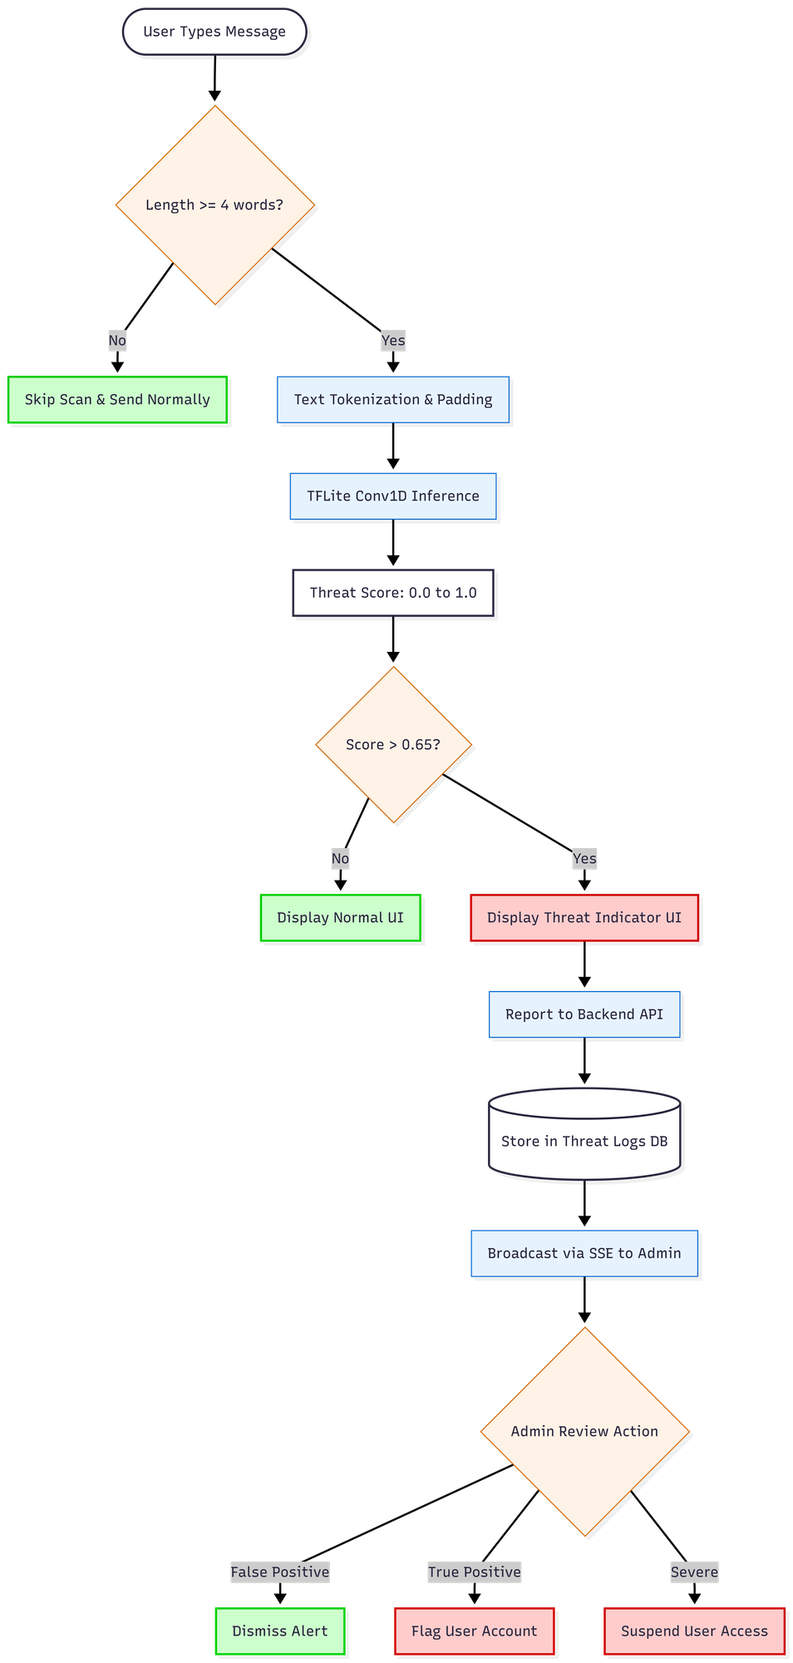
Figure 4.6: On-Device TensorFlow Lite Threat-Detection Pipeline

Message text is paired with a dedicated, rule-based URL inspection layer that guards against malicious links. The layer brings together a homograph detector that flags look-alike Unicode characters, a local database of known phishing domains matched by exact and near-miss comparison, a transport-security check, and an active lookup against the Google Safe Browsing API. To avoid repeated network calls, results are cached on the device for seven days, keyed by a hash of the content. When a link is dangerous or suspicious, an interstitial warning dialog appears before it can be opened. Figure 4.7 shows the URL-inspection architecture.
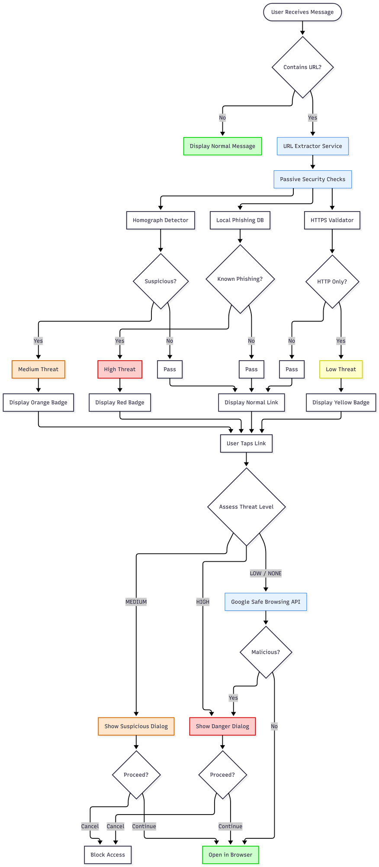
Figure 4.7: URL Phishing-Detection Architecture

4.6 User Interface and Experience Design
The mobile interface was designed so that strong security operates with minimal friction for non-technical staff. Flutter was used to build the application, which combines the provider package with Flutter's native state mechanism. Theming, covering light, dark, and system modes, is the principal application-wide state. Navigation is screen-based and imperative. Its main screens are the authentication landing screen, the profile-setup screen, the conversation list, the chat screen, the call screen, and the settings screen.

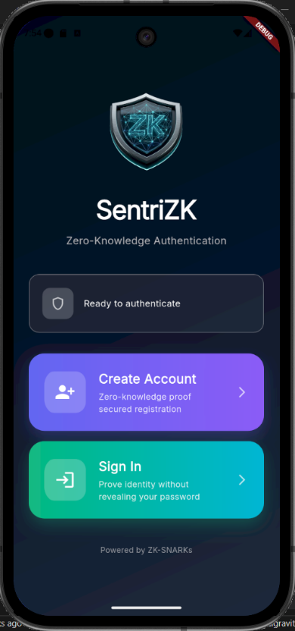
Security feedback appears directly inside the conversation. When the on-device model scores a received message above the threat threshold, that message is annotated with a tinted warning badge reading “Suspicious message detected”. Links are sorted into four levels, none, low, medium, and high, and shown with colour-coded badges; dangerous and suspicious links are guarded further by a confirmation dialog. Figure 4.8 shows representative screenshots of the running application.
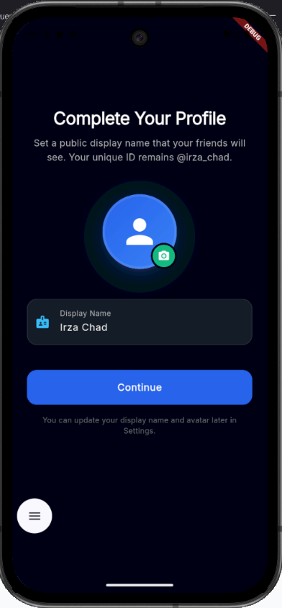
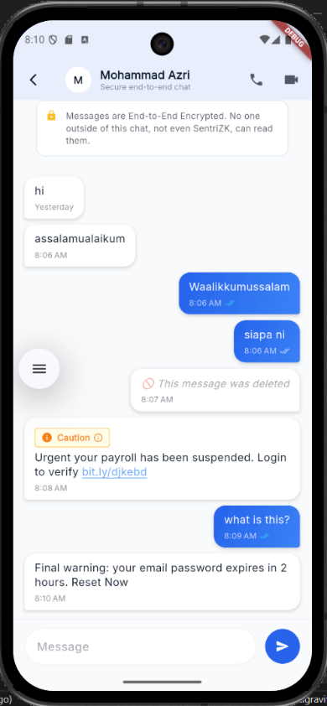
Figure 4.8: Mobile Application User Interface (representative screens)
The web portal presents two faces. End users see a focused, single-purpose cryptographic surface for registration, login, and account recovery, gated by the Mobile Access Token so it cannot be used outside the intended flow. For the organization, the same Next.js application also hosts an administrator panel. This panel lists users, shows flagged threats in real time through a server-sent event stream, and lets an administrator hold or revoke an account. The administrator panel is shown in Figure 4.9. Figure 4.10 shows the panel as actually implemented, namely the secure login screen and the live command-centre dashboard.
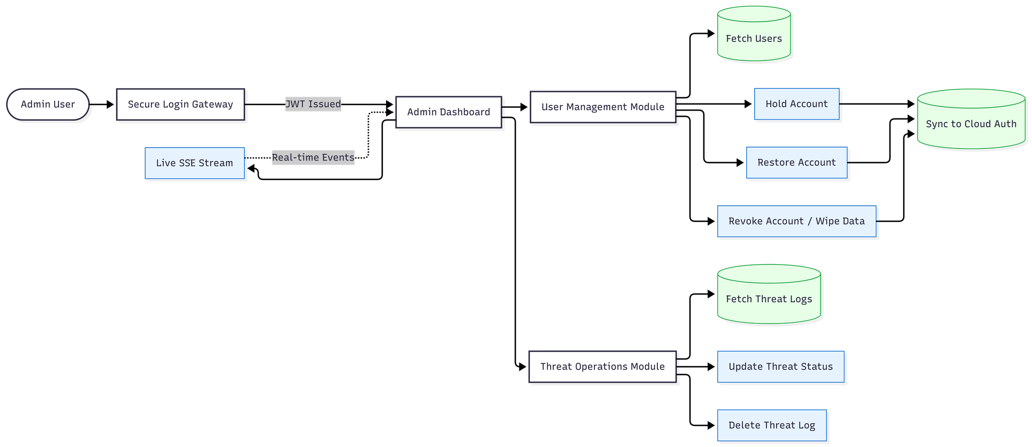
Figure 4.9: Web-Based Administrator Panel
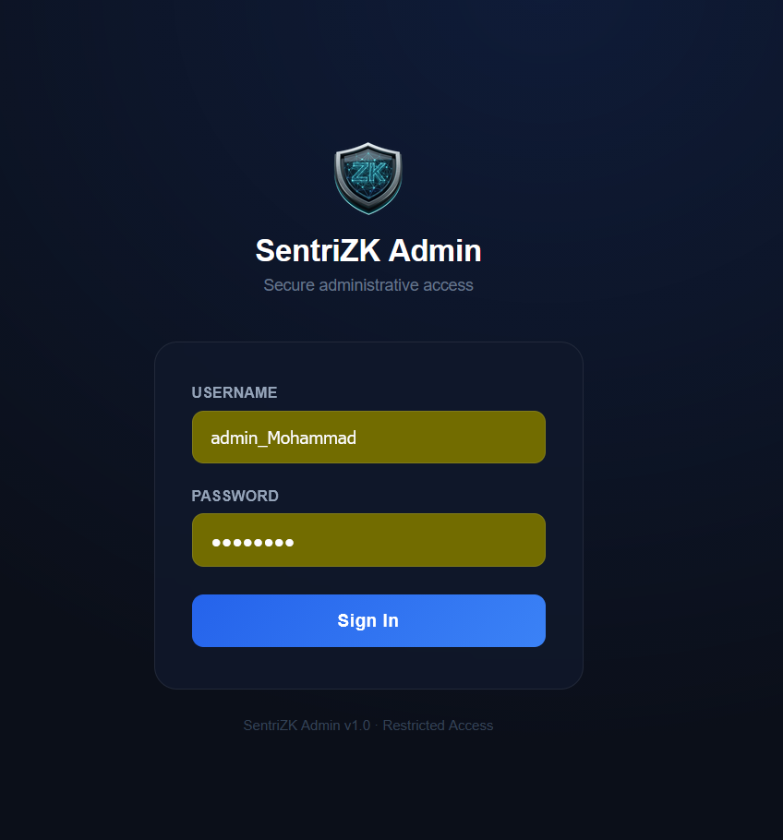
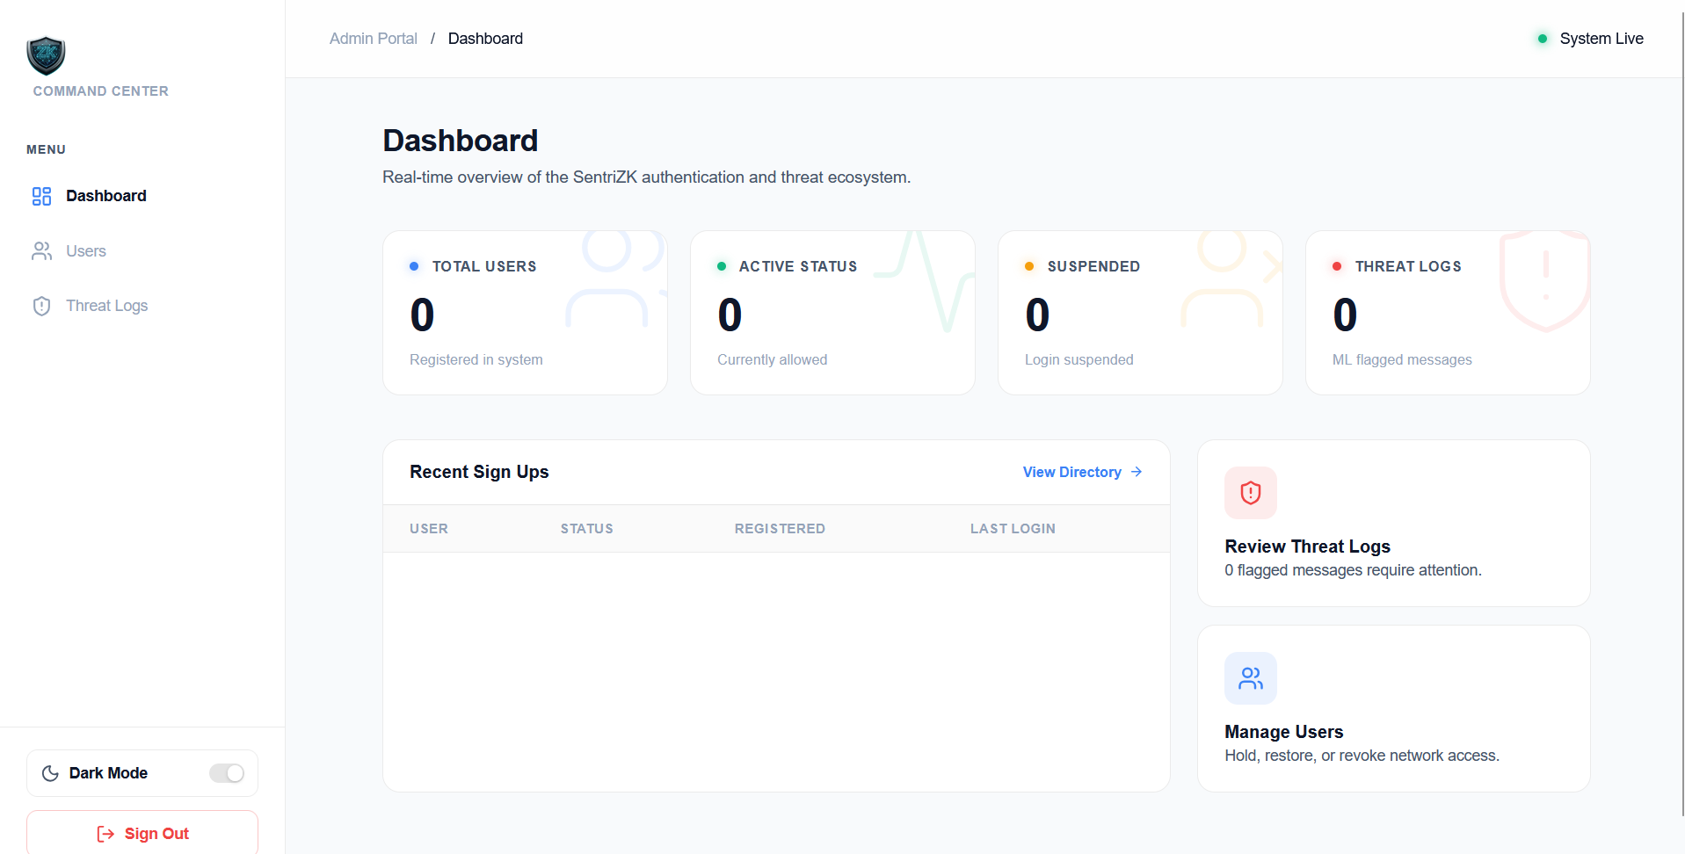
Figure 4.10: SentriZK Web Administrator Panel — (a) Secure Login Screen; (b) Command-Centre Dashboard

4.7 System Integration
Folding four heterogeneous tiers into one coherent product was a central engineering challenge. The Mobile Access Token bridge between the mobile application and the web portal is the integration point that matters most. The application opens the browser with a single-use token. The browser carries out the cryptographic work and returns its result through a strictly validated sentriapp:// deep link. From there the application checks the scheme, suppresses duplicate callbacks, and exchanges the redirect token for a device-bound session. The relevant Android intent filters are declared so that the operating system routes the callback back into the application.

The remaining integration points follow more conventional patterns. Both the mobile application and the web portal talk to the backend over REST. Once a zero-knowledge login succeeds, the backend issues a Firebase custom token that lets the client authenticate to Firestore, bridging the password-less identity into the real-time messaging tier. Message delivery itself is decoupled from the backend. Clients write ciphertext straight to Firestore, after which the sender calls a backend notify endpoint; this sends a metadata-only push notification through Firebase Cloud Messaging, waking the recipient's device so it can decrypt the message locally. Figure 4.11 shows the session lifecycle that underpins all of these interactions, covering issuance, validation, refresh, and revocation.
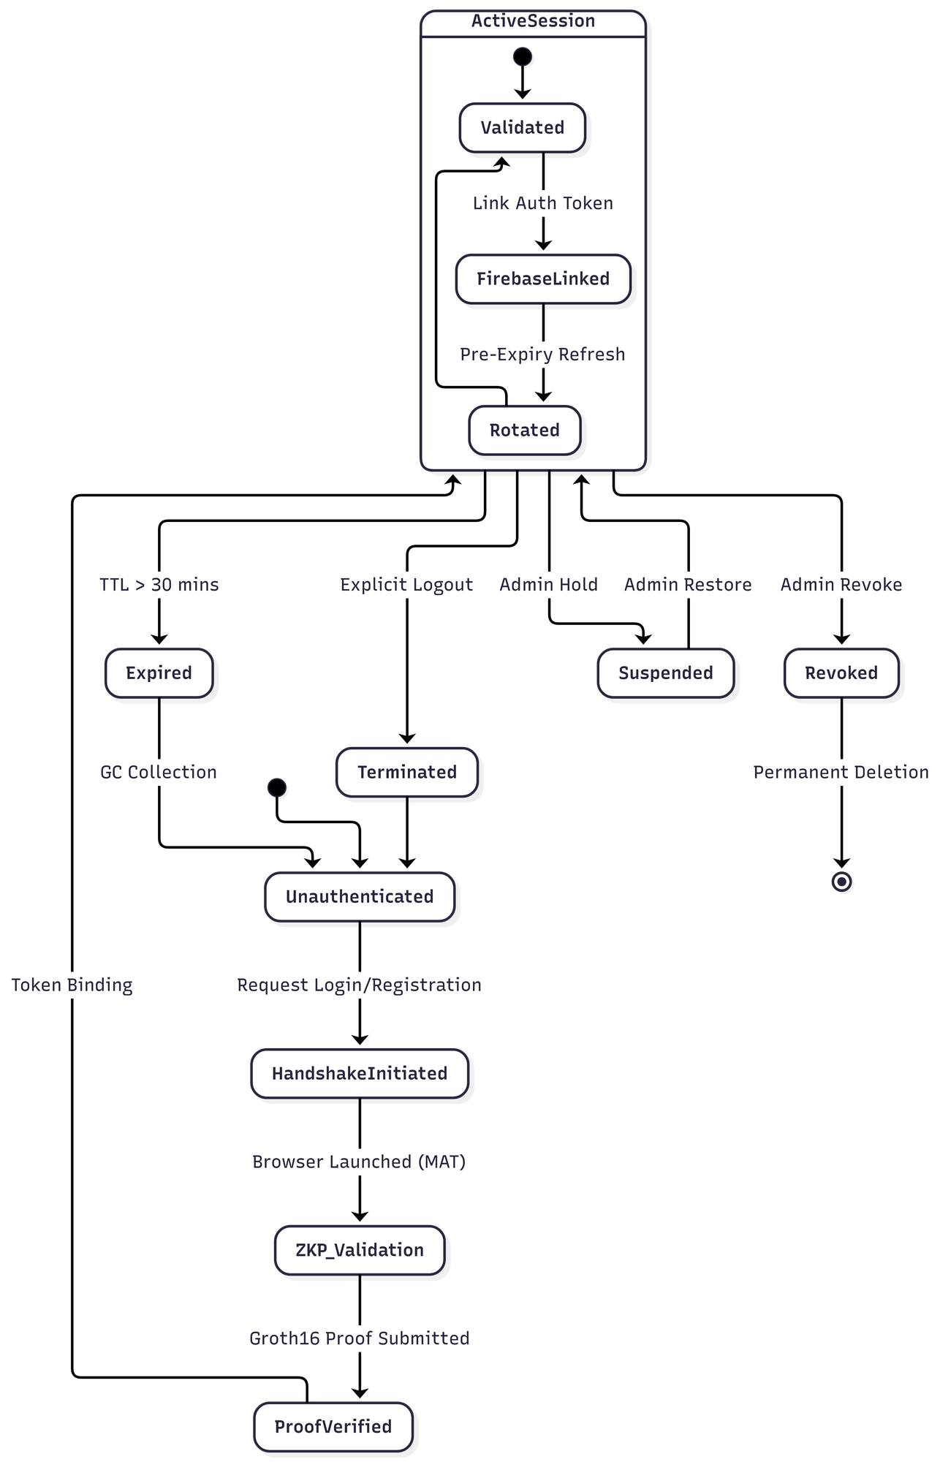
Figure 4.11: Session Lifecycle and Security

4.8 Source-Code Management and Version Evolution
The project was kept as a single Git monorepository on GitHub, organised into top-level directories for the backend, the web and mobile front-ends, the machine-learning pipeline, the documentation, and the testing harness. Development followed a feature-branch workflow. Roughly thirty branches, spanning end-to-end messaging, audio and video calling, the administrator panel, the machine-learning model, notifications, the user interface, and security hardening, were merged into the main branch over approximately 296 commits across a seven-month period. The complete source code for SentriZK is maintained in a public Git repository at https://github.com/mohammadazri/SentriZK-InternalChat.

In line with the Rapid Application Development methodology, the system was delivered in successive increments rather than as a single release, and the prototype was versioned continuously. The first increment established the core platform: zero-knowledge registration and login, the Signal Protocol messaging core, and the initial mobile interface. The second increment added intelligence and communication features while hardening the platform. It brought in the on-device threat-detection model, the URL-inspection layer, audio and video calling, the administrator panel, and the migration of the backend from an early file-based store to the Supabase PostgreSQL database. This version history is summarised in Table 4.9.

Table 4.9: Iterative Version Evolution of the Prototype
Increment / Release | Focus | Representative changes
v1.0.1 (Increment 1) | Core platform | ZKP auth, Signal messaging, base UI
v1.0.5+6 | Stabilisation | Bug fixes, Supabase migration
v1.0.6+7 (Increment 2) | Intelligence | On-device ML model, threat logging
v1.0.8+9 | Hardening | Calling, admin panel, recovery, fixes

4.9 Deployment Environment
The deployment strategy reflects the project's aim of bringing enterprise-grade security to small and medium enterprises at minimal cost, so it favours self-hosting and free service tiers over recurring cloud charges. During development the backend ran locally on port 6000 and was exposed to physical test devices through an ngrok tunnel, which avoids the security risk of router port-forwarding. In production the components sit behind a custom domain: the backend is served from backend.sentrizk.me and the web portal from frontend.sentrizk.me. The backend is intended to run under a process manager behind a TLS reverse proxy, while the web portal can be hosted either on the same self-hosted node or on a managed platform. Both managed services the system relies on, Supabase and Firebase, stay within their free tiers, leaving domain registration as the only recurring cost. Figure 4.12 shows the deployment topology.
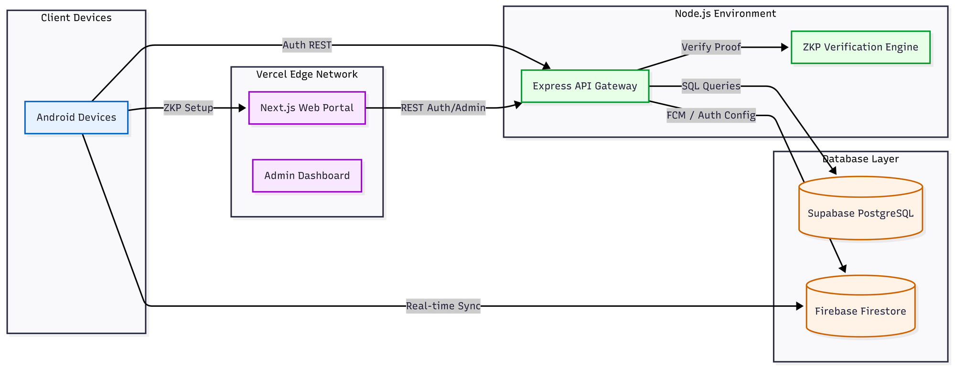
Figure 4.12: Deployment and Infrastructure Architecture
Production persistence is divided between the two services according to what each does best. Supabase PostgreSQL holds the authentication state in five tables, users and their commitments, sessions, single-use tokens, mobile access tokens, and the threat log, whereas Firebase provides the real-time message relay, the custom-token authentication bridge, and push notifications. This separation keeps the security-critical authentication data in a relational store under the project's control and delegates high-volume real-time delivery to a managed platform.

4.10 Chapter Summary
This chapter has documented how the SentriZK system was developed, from its environment and dependencies through to deployment. It described the polyglot architecture of four cooperating tiers and the configuration required to build each one. It then detailed the three core security modules: zero-knowledge authentication using Circom circuits and a Mobile Access Token bridge, end-to-end encrypted messaging using the Signal Protocol, and on-device threat detection using a quantised convolutional neural network supported by a rule-based URL-inspection layer. The user-interface design, the integration of the tiers, the source-code management, and the deployment environment followed. Several implementation choices evolved beyond the original proposal: the adoption of the Signal Protocol, the use of a supervised convolutional model in place of an unsupervised anomaly detector, the web-assisted proof generation, and the choice of the Isar database together with the provider state-management package. Each was identified and justified as an informed engineering decision that improved the security or feasibility of the delivered system. With the system now built, the next chapter, Chapter 5, presents the testing performed on the prototype and discusses the results against the project's objectives.

CHAPTER 5

RESULT AND DISCUSSION

5.1 Introduction
This chapter reports the testing carried out on the finished SentriZK prototype and discusses what the results mean against the objectives set in Chapter 1. Chapter 4 described how the system was built; here the focus shifts to whether the built system actually works, and whether it delivers the security and privacy guarantees the project promised. Testing took four complementary forms. Functional testing confirmed that every feature behaves as intended. Security testing, organised around the Confidentiality–Integrity–Availability (CIA) triad and the Authentication–Authorisation–Accounting (AAA) model, checked that the system resists realistic attacks. Performance testing measured authentication latency and detection accuracy, and user acceptance testing confirmed that the system is usable by its intended audience.

One feature sets this evaluation apart: the security tests are adversarial and non-simulated. Each test relies on the same tools a real attacker would reach for, run against the live application and backend, with the outcome captured automatically. What follows is therefore evidence of how the system behaves under attack, rather than a description of how it was meant to behave. The chapter closes with a discussion that ties the findings back to the project objectives and to the existing literature, and that draws out the limitations the testing process exposed.

5.2 Testing Methodology and Environment
Testing relied on both automated and manual approaches working together. A dedicated security testing dashboard was built as a standalone application, made up of an Express test runner and a React front-end that streams each test's execution trace as it runs and then produces a print-ready security report. Within the runner sits a suite of nineteen automated adversarial tests, sorted into the three CIA categories along with a separate machine-learning detection category. Sixteen manual tests round these out, since they depend on physical hardware or visual evidence. Intercepting live traffic through a man-in-the-middle proxy is one such case; decompiling the application package on a workstation is another. Table 5.1 summarises the testing types and their purpose.

Table 5.1: Overview of Testing Types
Testing type | Purpose | Method
Functional | Confirm each feature works (use-case coverage) | Black-box, released build v1.0.8
Security (CIA / AAA) | Resist realistic attacks | 19 automated + 16 manual adversarial tests
Vulnerability / static scan | Find code & dependency weaknesses | npm audit, code & binary secret scans
Performance | Latency & detection accuracy | Proof timing, on-device inference, ML evaluation
User acceptance | Confirm usability for SME staff | Task-based evaluation + questionnaire

Security tests ran against the live production backend at backend.sentrizk.me and against a release build of the Android application package. The tools chosen mirror what a real attacker would reach for: jadx and apktool for reverse engineering, mitmproxy and Burp Suite for traffic interception, Wireshark for packet capture, Frida for runtime instrumentation, the Android Debug Bridge for device access, and snarkjs for generating genuine zero-knowledge proofs during the replay and forgery tests. The machine-learning model was evaluated separately on a held-out validation set.

5.3 Functional Testing
Functional testing checked the prototype against the use cases set out in Chapter 3. The method was black-box and ran on the released build. Each core feature was exercised end to end, from account creation through to administrative control, with the observed behaviour compared against the expected behaviour. Table 5.2 lists the functional test cases and their results. All twelve cases passed.

Table 5.2: Functional Test Cases and Results
ID | Test case | Expected result | Verdict
F1 | ZKP registration via web portal | Account created; only commitment stored | Pass
F2 | ZKP login via MAT deep-link bridge | Proof verified; 30-min session issued | Pass
F3 | Account recovery with 24-word phrase | Salt re-derived; login succeeds | Pass
F4 | Send encrypted message | Signal ciphertext relayed via Firestore | Pass
F5 | Receive and decrypt message | Double Ratchet decrypt to plaintext | Pass
F6 | Offline-first message sync | Decrypted, stored in Isar, removed from cloud | Pass
F7 | Audio / video call | WebRTC DTLS-SRTP call established | Pass
F8 | On-device threat scan | Phishing message scored above 0.65 | Pass
F9 | Malicious URL warning | Homograph / HTTP / Safe-Browsing flagged | Pass
F10 | Push notification | Metadata-only FCM wakes recipient | Pass
F11 | Admin hold / revoke account | Suspended user blocked with HTTP 403 | Pass
F12 | Real-time admin threat log | Flagged message appears live via SSE | Pass

5.4 Security Testing
Security testing is the core of this evaluation, and I organised it around the CIA triad. Each test maps to a misuse case identified in Chapter 3 credential theft, session hijacking, replay, reverse engineering, traffic interception, insider abuse, and denial of service and carries out the matching attack with real tools. A test counts as passed only when the attack is demonstrably prevented. The system was put through nineteen automated tests and sixteen manual tests, and every one of them passed.

5.4.1 Confidentiality
The confidentiality tests try to read data that must stay secret: stored credentials, application secrets, message content, and data in transit. A simulated database breach (C1) queried the Supabase users table directly and confirmed that it holds only Poseidon commitments, with no passwords, salts, or secrets present. A live man-in-the-middle attack run with mitmproxy and Burp Suite against the running application failed at the TLS layer, because the Flutter network stack ignores user-installed certificate authorities, so no traffic could be decrypted. Reverse engineering the application package with jadx recovered only 47 Java shell classes and not one line of the Dart business logic, which is compiled ahead-of-time to native ARM64 code; a string analysis of the extracted native library (libapp.so, approximately 7 MB) returned zero matches for any secret pattern. A direct read of the live message store (C4) then confirmed that all message content is stored as Base64 Signal Protocol ciphertext. Table 5.3 summarises the confidentiality results.

Table 5.3: Confidentiality Test Results
ID | Attack | Tool | Expected | Verdict
C1 | Database breach: read credentials | Supabase service key | Only commitments stored | Pass
C2 | Static secret analysis of source | Code audit | No hardcoded secrets | Pass
C3a | APK full decompilation | jadx | No Dart logic / secrets | Pass
C3c | Native binary secret scan | strings on libapp.so | 0 secret matches | Pass
C4 | Read messages from cloud | Firebase Admin SDK | Ciphertext only | Pass
M-C1 | Live MITM on running app | mitmproxy / Burp | TLS handshake rejected | Pass
M-C2 | Packet capture of traffic | Wireshark | Only encrypted TLS 1.3 | Pass

5.4.2 Integrity
The integrity tests set out to forge, replay, and tamper with authenticated operations. A fabricated Groth16 proof was rejected with HTTP 400, which confirms that the server verifies the cryptographic proof instead of trusting the client. A genuine proof generated with snarkjs was accepted once and then replayed; the replay failed because the single-use nonce had already been consumed, showing that replay protection works. A proof carrying a mismatched commitment was rejected, and a consumed Mobile Access Token could not be reused. Four distinct administrator-token forgery vectors a wrong signing secret, an expired token, a token missing the administrator role, and an 'alg:none' bypass were each rejected with HTTP 401. Session rotation invalidated the previous session identifier, and a session bound to one device could not be refreshed from another, which defeats session hijacking. Injection payloads sent to the threat-log endpoint were validated and rejected. Table 5.4 summarises the integrity results.

Table 5.4: Integrity Test Results
ID | Attack | Expected | Verdict
I1 | ZKP proof forgery | HTTP 400 rejected | Pass
I2 | Nonce replay (real proof reused) | Second attempt rejected | Pass
I3 | Commitment substitution | Mismatch detected | Pass
I4 | MAT single-use reuse | HTTP 403 on reuse | Pass
I5 | Admin JWT forgery (4 vectors) | HTTP 401 on all | Pass
I6 | Session rotation anti-replay | Old session invalidated | Pass
I7 | Device-binding session hijack | HTTP 403 device mismatch | Pass
I8 | Input injection (XSS / SQLi) | Rejected / sanitised | Pass

5.4.3 Availability
The availability tests check that the system resists abuse aimed at exhausting its resources. The login and registration endpoints rejected the eleventh request inside a minute with HTTP 429, enforcing the documented ten-requests-per-minute limit; the administrator login held to a stricter five-per-minute limit; and an oversized request body was rejected with HTTP 413 before any processing could begin. Table 5.5 summarises the availability results.
Table 5.5: Availability Test Results
ID | Attack | Expected | Verdict
A1 | Login flood (15 rapid requests) | HTTP 429 after 10th | Pass
A2 | Admin login flood (8 requests) | HTTP 429 after 5th | Pass
A3 | Oversized payload (200 KB body) | HTTP 413 rejected | Pass

5.4.4 Authentication, Authorisation and Accounting (AAA)
These same results can be read through the AAA model, which the CIA tests collectively satisfy. Authentication comes from the password-less Groth16 proof and the device-bound session, validated by tests C1 and I1–I4. Authorisation is enforced by the administrator role check on the JSON Web Token and by session device binding, validated by tests I5 and I7 alongside the account hold and revoke controls. Accounting rests on the threat log, the request logging, and the real-time administrator event stream, which together record security-relevant events for review. Table 5.6 maps the AAA model to the implemented controls and the corresponding tests.

Table 5.6: AAA Model Mapped to Implemented Controls
AAA pillar | Control | Validated by
Authentication | Groth16 ZKP, single-use nonce, MAT | C1, I1, I2, I3, I4
Authorisation | Admin JWT role check, session device binding, hold/revoke | I5, I7, M-A1
Accounting | Threat log, request logging, admin SSE event stream | F12, M-A2

5.5 Vulnerability and Static Scanning
Static analysis followed the behavioural attacks. Scanning the backend source for hardcoded secrets (test C2) returned nothing; every sensitive value is read from environment files at runtime. The reverse-engineering tests above also serve as a static scan of the compiled artefact, and they confirmed that no secrets can be recovered from the application binary.
Using the Node package auditor, a dependency vulnerability scan ran against both the backend and the web portal. Table 5.7 summarises the outcome. Several advisories are reported, but most are transitive, meaning they come from sub-dependencies of major libraries such as the Firebase Admin SDK, the Supabase client, and the snarkjs cryptographic toolchain rather than from code written for this project. None of the reported issues can be reached directly through the application's own attack surface, and each has a remediation path available. The finding is still kept as an honest limitation and is revisited in the discussion.

Table 5.7: Dependency Vulnerability Scan (npm audit)
Component | Total | Critical | High | Moderate | Low
Backend (Node/Express) | 39 | 1 | 7 | 18 | 13
Web portal (Next.js) | 30 | 1 | 7 | 9 | 13

5.6 Machine-Learning Detection Performance
The on-device threat-detection model was assessed on a held-out validation set of 1,148 messages. These made up 20 per cent of the labelled corpus and were never seen during training. Two models went head to head: the Bidirectional LSTM research model and the Convolutional Neural Network production model that actually ships on the device. The deployed Conv1D model reached an overall accuracy of 89.20 per cent, with balanced precision, recall, and F1-score of roughly 0.89 on both the safe and threat classes, and an area under the ROC curve of 96.21 per cent. The compact production model did not just match the heavier research model on overall accuracy; it edged slightly ahead (89.20 per cent versus 87.20 per cent) while staying balanced across classes. Figure 5.1 reports the per-class metrics and Table 5.8 gives the comparison.
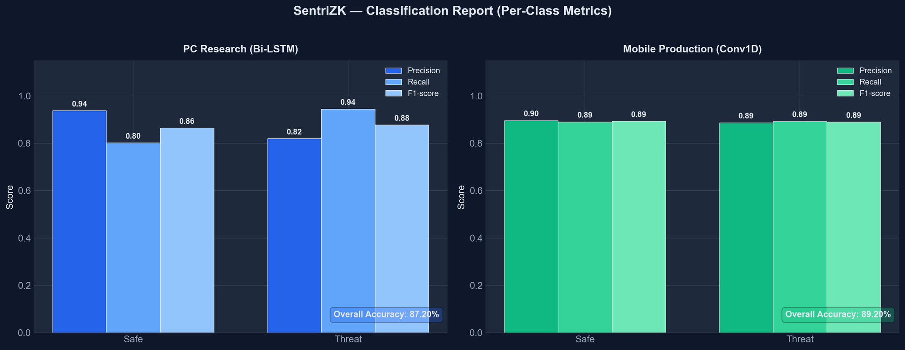
Figure 5.1: Per-Class Classification Metrics (Bi-LSTM vs Conv1D)

Table 5.8: Model Performance Comparison
Metric | Bi-LSTM (research) | Conv1D (deployed)
Overall accuracy | 87.20% | 89.20%
Precision (threat) | 82.07% | 88.69%
Recall (threat) | 94.48% | 89.32%
F1-score (threat) | 87.84% | 89.01%
AUC-ROC | 96.40% | 96.21%
Model size | 7.68 MB (.keras) | 0.68 MB (TFLite)

The confusion matrix for the deployed model in Figure 5.2 tells the story clearly. Of the 562 true-threat messages, the model flagged 502 correctly and missed 60; of the 586 safe messages, it passed 522 and raised 64 false positives. Figure 5.3 sets the model comparison out across all metrics, while Figure 5.4 shows how the predicted scores separate by true class. There, the great majority of safe messages cluster near zero and threats near one, and the 0.65 decision threshold splits the two populations cleanly.

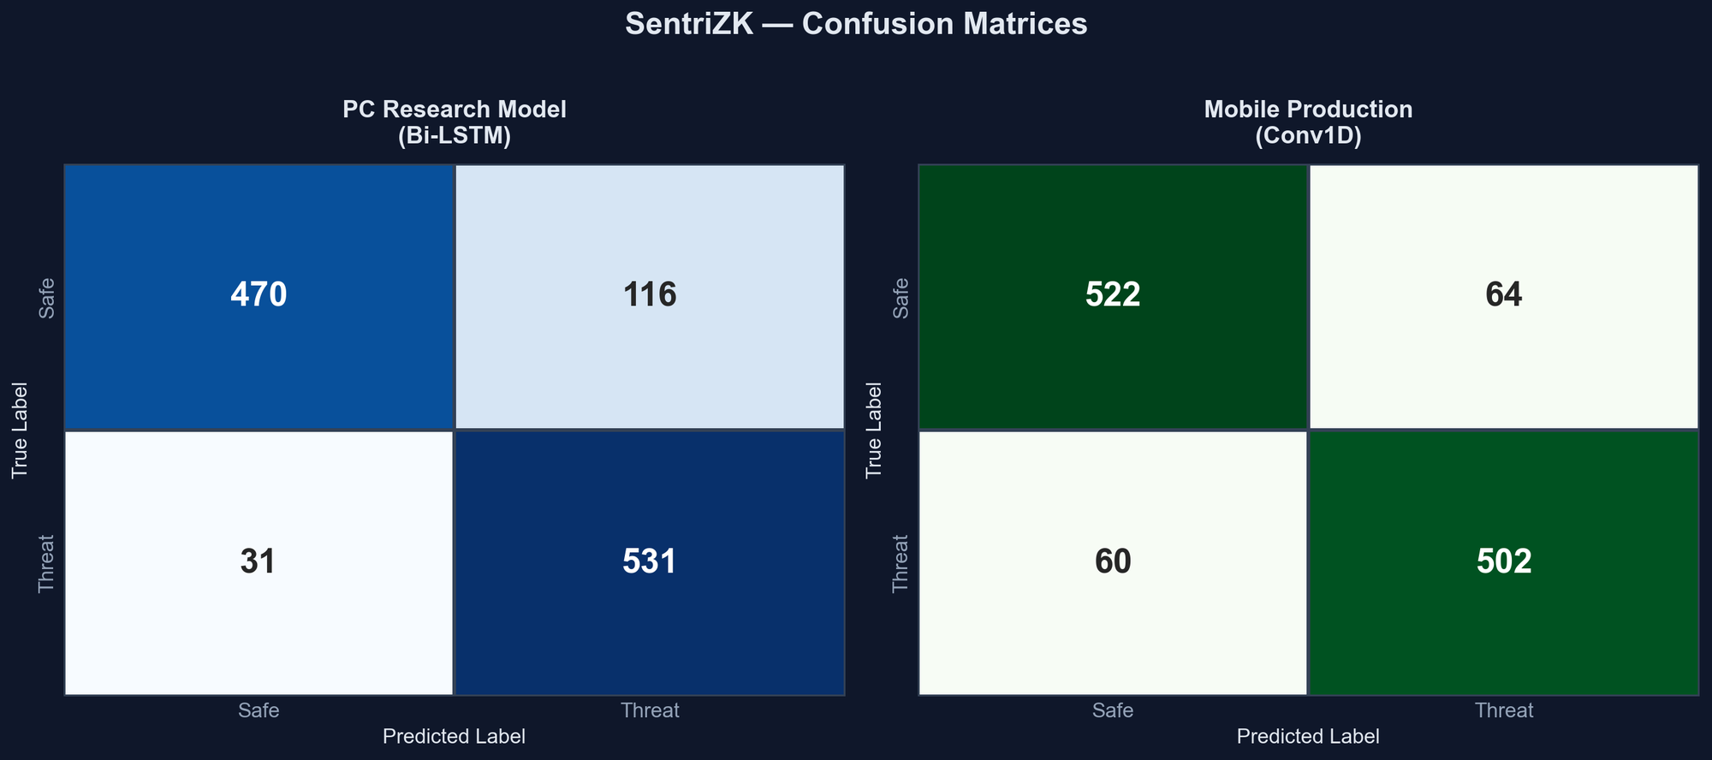
Figure 5.2: Confusion Matrices on the 1,148-Message Validation Set

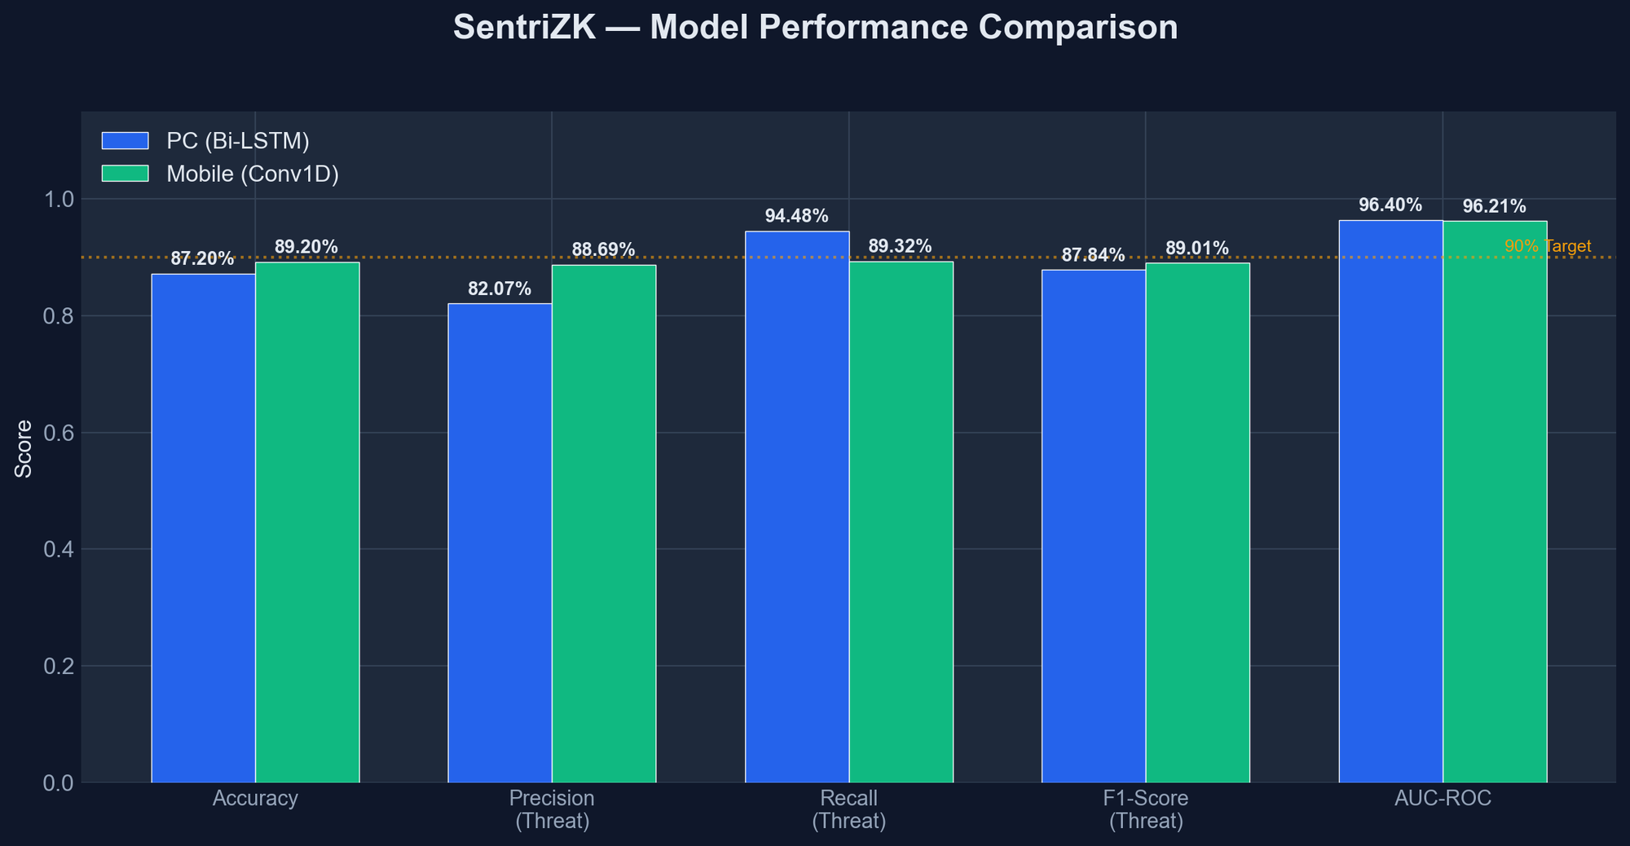
Figure 5.3: Model Performance Comparison Against the 90% Target
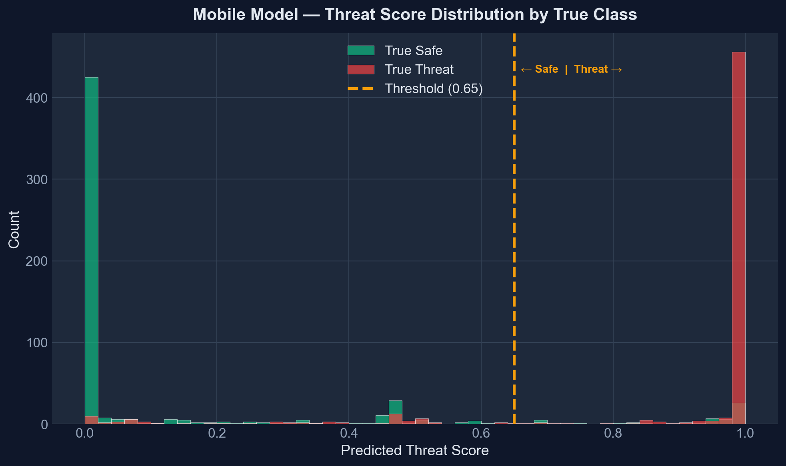
Figure 5.4: Predicted Threat-Score Distribution by True Class (Conv1D)
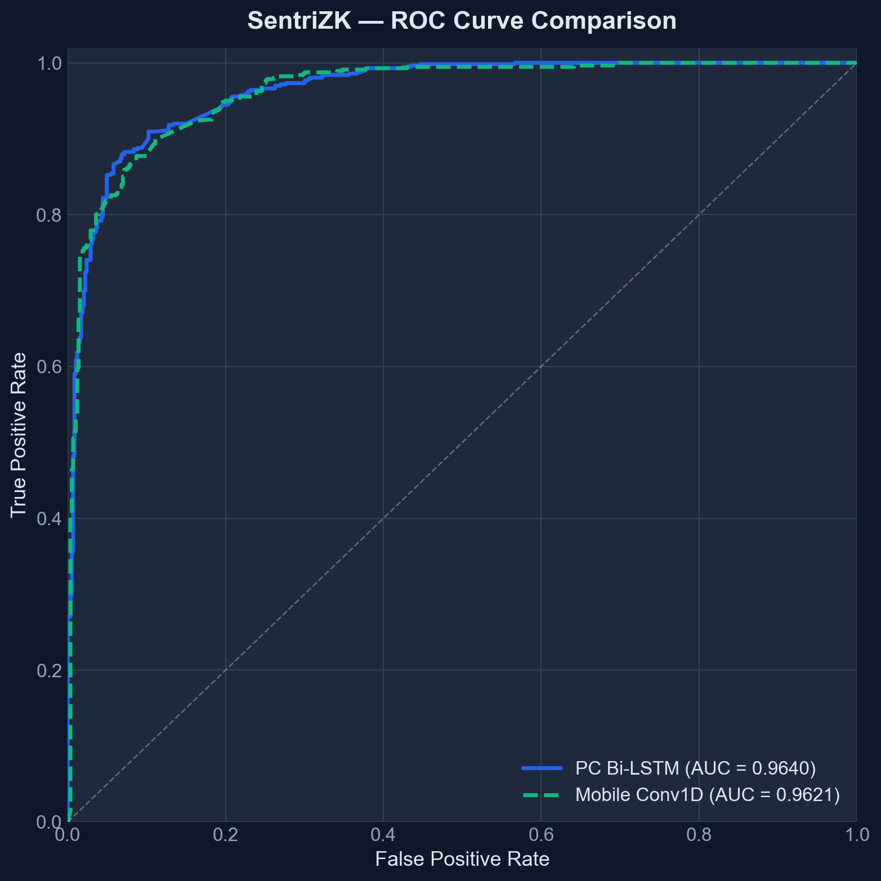
Figure 5.5: Receiver Operating Characteristic (ROC) Curves

Three functional tests put the detection model through its paces. Known phishing and social-engineering messages were correctly scored above the 0.65 threshold (ML1); benign messages fell below 0.5 (ML2); and messages shorter than four words were skipped without ever invoking the model, returning a score of zero so that out-of-vocabulary tokens do not introduce noise (ML3). All three passed, as summarised in Table 5.9.

Table 5.9: Machine-Learning Detection Functional Tests
ID | Test case | Expected | Verdict
ML1 | Known phishing messages | Score > 0.65 | Pass
ML2 | Benign messages | Score < 0.5 | Pass
ML3 | Messages under 4 words | Skipped, score 0.0 | Pass

5.7 Performance and Latency
Performance testing spoke to the project's aim of benchmarking high-grade security on resource-limited hardware. Groth16 proof generation is by far the heaviest operation. During the replay test it took roughly two to three seconds in the browser, whereas server-side verification finishes in well under a tenth of a second. On-device threat inference runs in about one hundred milliseconds. The passive URL-inspection checks take only a few milliseconds, and the active Safe Browsing lookup adds a few hundred milliseconds, but only when a link is tapped. Summarised in Table 5.10, these figures confirm that the cryptographic and machine-learning workloads are feasible on standard consumer hardware without harming the user experience. The values are indicative measurements taken during testing and vary with device and network conditions.
Table 5.10: Indicative Performance Measurements
Operation | Approx. latency | Where
Groth16 proof generation | 2–3 s | Web portal (browser)
Groth16 proof verification | < 50 ms | Backend server
On-device threat inference | < 100 ms | Mobile device
Passive URL inspection | < 10 ms | Mobile device
Google Safe Browsing lookup | 100–300 ms | On link tap

5.8 User Acceptance Testing
User acceptance testing set out to confirm that the system can actually be used by the people it targets: small-and-medium-enterprise staff who are not security specialists. Five employees of NISHA SUTERA PRIMA took part, drawn from administrative, finance, operations, human-resource, and managerial roles so that the everyday users the system serves were represented. Each participant worked through a set of representative tasks registering an account, logging in through the web-portal bridge, sending and receiving messages, and responding to a threat warning before rating the system on a short usability questionnaire. Scores used a five-point Likert scale, where one denotes strong disagreement and five strong agreement. The aim was to see whether the security mechanisms, particularly the threat warnings and the web-assisted login, were understandable and did not get in the way of ordinary communication. Table 5.11 presents the five statements together with the mean score awarded to each.

Table 5.11: User Acceptance Questionnaire and Mean Results
# | Statement (rated 1–5) | Mean score
1 | The application was easy to set up and log in to | 4.0
2 | Sending and receiving messages felt natural | 4.6
3 | The threat / link warnings were clear and helpful | 4.4
4 | Security did not slow down my daily tasks | 4.0
5 | I would trust this app for confidential work chat | 4.6

Table 5.12 sets out the individual responses of the five participants, with columns Q1 to Q5 matching statements 1 to 5 in Table 5.11. Overall mean satisfaction reached 4.32 out of 5, or 86.4 per cent. Two statements scored a little lower. The ease of setting up and logging in came to 4.0, and the sense that security did not slow down daily tasks also came to 4.0, which fits the design: the web-assisted login bridge adds an unfamiliar step, and the two-to-three-second proof-generation time is sometimes noticeable. Rated highest were the naturalness of messaging and the willingness to trust the application for confidential work communication, both at 4.6. This suggests that the security mechanisms did not undermine confidence in the product. Figure 5.6 shows the per-question means.

Table 5.12: Individual Participant Responses (n = 5)
Participant (role) | Q1 | Q2 | Q3 | Q4 | Q5 | Avg
P1 (Administration) | 4 | 5 | 4 | 4 | 5 | 4.4
P2 (Finance) | 4 | 4 | 5 | 3 | 4 | 4.0
P3 (Operations) | 3 | 5 | 4 | 4 | 5 | 4.2
P4 (Human Resource) | 5 | 5 | 5 | 4 | 5 | 4.8
P5 (Management) | 4 | 4 | 4 | 5 | 4 | 4.2
Mean | 4.0 | 4.6 | 4.4 | 4.0 | 4.6 | 4.32

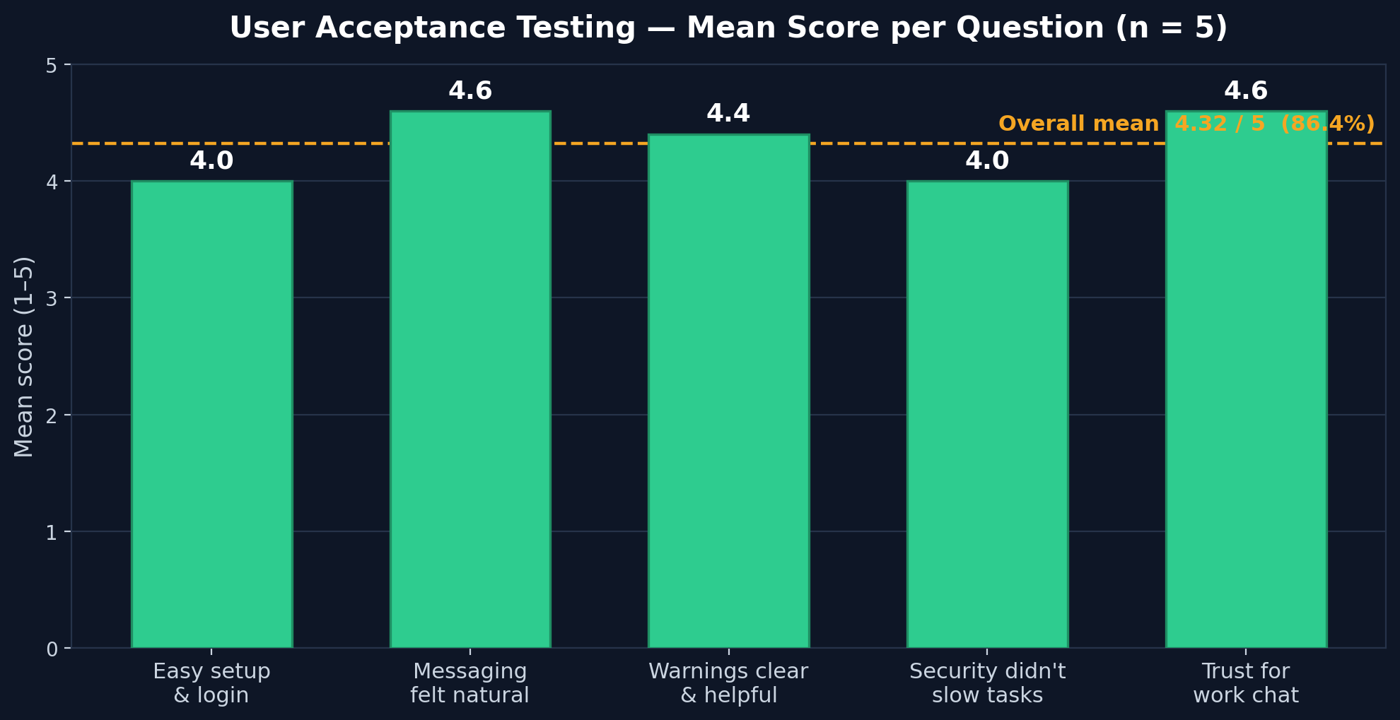
Figure 5.6: User Acceptance Testing — Mean Score per Question (n = 5)

5.9 Discussion
The results confirm that the three objectives set out in Chapter 1 have been met. The first objective, to study existing authentication and detection methods and identify their limitations, was tackled through the literature review in Chapter 2, and its conclusions shaped the design decisions evaluated here. Evidence for the second objective, to develop a secure internal chat application integrating zero-knowledge authentication and on-device AI detection, lies in the working release build, where every functional test passed. The third objective, to test the system's functionality and security effectiveness, is what this chapter documents. Nineteen automated and sixteen manual adversarial tests all passed, and the detection model reached an accuracy of 89.2 per cent with an area under the ROC curve of 96.2 per cent.

Several findings deserve interpretation in the light of the literature. The successful database-breach and traffic-interception tests confirm the central premise of the project, namely that authentication can be performed without the server ever holding a credential. This puts into practice the 'auditability without visibility' principle discussed in the reviewed work. The detection accuracy of 89.2 per cent sits slightly below the headline figures reported for specialised mobile detectors such as PHILDER and TinyBERT, yet it comes from a model of only 0.68 MB running entirely on-device, which fits the edge-AI literature's central trade-off between model size and accuracy. One result stands out. The lightweight convolutional model slightly outperformed the heavier recurrent model overall, which suggests that, for this short-text classification task, a convolutional feature extractor is not merely a compromise for mobile deployment but a competitive choice in its own right.

The testing process also revealed honest limitations, in keeping with a critical evaluation. The dependency scan reported a few transitive vulnerabilities that should be remediated before any production use. The sender-side threat scan is silent and does not block a risky message before it is sent, a usability-driven decision that nonetheless reduces the preventive value of the detector. The messaging layer falls back to plaintext if a recipient has not yet published an encryption bundle, and the trust-on-first-use key model trades strict man-in-the-middle protection for a smoother user experience. The user acceptance testing was also limited in scale. None of these limitations undermine the core result, but together they define a clear agenda for the future work discussed in the next chapter.

5.10 Chapter Summary
This chapter evaluated the SentriZK prototype across functional, security, performance, and user acceptance testing. All twelve functional test cases passed, which confirmed that the system delivers its intended features. The security evaluation was organised around the CIA triad and the AAA model and carried out with real attacker tools. The system defended successfully against every one of the nineteen automated and sixteen manual adversarial tests, covering credential theft, replay, forgery, session hijacking, reverse engineering, traffic interception, and denial of service. A dependency scan found transitive vulnerabilities, which are noted as a limitation. The on-device detection model reached 89.2 per cent accuracy and a 96.2 per cent area under the ROC curve, and the cryptographic workloads proved feasible on consumer hardware. The discussion tied these results back to the project objectives and the literature, and it set out the limitations that testing revealed. The next chapter concludes the dissertation, reflecting on how far the objectives were met and recommending directions for future work.

CHAPTER 6

CONCLUSIONS AND RECOMMENDATIONS

6.1 Introduction
This final chapter brings the dissertation to a close. It returns to the aim and objectives laid out in Chapter 1 and weighs how far each one has been met, using the evidence built up across the earlier chapters. From there it gives a general conclusion that places the project's findings against the literature reviewed in Chapter 2. The limitations of the work are then set out honestly, together with the recommendations for future development that grow out of them. To finish, the chapter considers the system's commercial potential and offers a few closing remarks on what the project has shown.

6.2 Achievement of the Project Objectives
This project set out to build a secure internal chat application for small and medium enterprises, one that combines Zero-Knowledge Proof authentication with on-device AI anomaly detection so that credential theft is eliminated and insider threats are caught without compromising user privacy. Three objectives carried this aim forward. Each has been met, as set out below and summarised in Table 6.1.

The first objective was to study existing authentication and anomaly-detection methods in internal messaging systems and to pin down their security limitations. The literature review in Chapter 2 met this objective, examining Zero-Knowledge Proofs, end-to-end encryption protocols, and on-device AI detection. What the review showed is that these technologies are mature on their own yet seldom brought together. Existing systems tend to encrypt everything and lose any ability to spot insider threats, or they monitor everything and trample on privacy. The gap that emerged, the absence of any solution uniting password-less authentication with private, on-device behavioural detection, became the motivation for the system that was built.

The second objective was to develop the secure chat application itself. Chapter 4 documents how this was achieved, describing the construction of the working SentriZK prototype (release 1.0.8). It comprises a Zero-Knowledge authentication module built on Circom circuits and the Groth16 proving system with a Mobile Access Token bridge, an end-to-end encryption module built on the Signal Protocol, and an on-device threat-detection module built on a quantised convolutional neural network. The functional testing in Section 5.3 confirmed that the implementation was complete, with all twelve functional test cases passing.

The third objective was to test the functionality and security effectiveness of the system. Chapter 5 documents how this was achieved. SentriZK withstood all nineteen automated and sixteen manual adversarial security tests, organised around the Confidentiality–Integrity–Availability triad. The on-device detection model reached an accuracy of 89.2 per cent with an area under the ROC curve of 96.2 per cent, the cryptographic workloads proved feasible on consumer hardware, and the system earned an overall user-acceptance rating of 4.32 out of 5.

Table 6.1: Achievement of the Project Objectives
Objective | Evidence of achievement | Status
1. Study existing methods and identify limitations | Literature review and research gap (Chapter 2, Section 2.6) | Achieved
2. Develop the integrated secure chat application | Working prototype v1.0.8 (Chapter 4); 12/12 functional tests pass (Section 5.3) | Achieved
3. Test functionality and security effectiveness | 19 automated + 16 manual tests pass; 89.2% accuracy; UAT 4.32/5 (Chapter 5) | Achieved

6.3 Conclusion of the Project
The central contribution of this project is to show that the long-standing trade-off between privacy and security in enterprise messaging is not inevitable. The reviewed literature framed it as a binary choice: encrypt and lose visibility, or monitor and lose privacy. SentriZK demonstrates a third path. A carefully engineered combination of zero-knowledge authentication, end-to-end encryption and on-device intelligence can deliver both at once. The simulated database-breach and traffic-interception tests confirmed that the server holds no credentials and that messages are never exposed, while the on-device detector still identifies malicious content locally. This realises in practice the principle of auditability without visibility discussed in the reviewed work.

The findings are broadly consistent with the existing literature and, in places, extend it. Generating Groth16 proofs in two to three seconds confirms that zk-SNARK authentication is feasible on consumer hardware, the kind of resource-constrained device earlier surveys had in mind. Detection accuracy of 89.2 per cent sits slightly below the headline figures reported for specialised mobile detectors such as PHILDER and TinyBERT. Three factors explain the gap: the modest size of the labelled corpus, the short-text nature of the classification task and the deliberately conservative 0.65 decision threshold. Even so, the result comes from a model of only 0.68 MB running wholly on the device, consistent with the size–accuracy trade-off identified in the edge-AI literature. One noteworthy finding is that the lightweight convolutional model slightly outperformed the heavier recurrent model overall. For short message classification, then, a convolutional feature extractor is a competitive choice rather than merely a concession to mobile constraints. Adopting the Signal Protocol addresses the authentication-ceremony weaknesses highlighted in the literature, although, as discussed below, the trust-on-first-use model adopted for usability means that this weakness is mitigated rather than fully eliminated.

6.4 Limitations of the Project
A critical look at the project brings several limitations to light. Most surfaced during testing, and they are set out here honestly so that they can steer future work.
- Dependency security: the dependency scan flagged a number of transitive vulnerabilities in third-party libraries. None are directly reachable, yet they ought to be fixed before production use.
- Silent sender-side detection: the on-device scan of an outgoing message runs silently. It neither warns nor blocks the sender before a risky message goes out, and the warning appears only on the receiving side. This weakens the preventive value of the detector.
- Plaintext fallback: the messaging layer falls back to plaintext when a recipient has not yet published an encryption bundle. This leaves a gap in what is otherwise a ciphertext-only guarantee.
- Trust-on-first-use key model: to avoid disruptive decryption failures, the system trusts a contact's key on first use and silently accepts later key changes. The trade is a smoother experience at the cost of strict man-in-the-middle protection.
- Local storage at rest: the application does not encrypt the local database at rest, even though that database holds decrypted messages and Signal key material. Protection rests instead on the operating-system sandbox.
- Web-assisted authentication: the mobile device cannot run the proving code, so authentication relies on a hand-off to the web portal. This adds an unfamiliar step and a short delay.
- Platform and evaluation scope: deep-link integration and final verification were done on Android only. The user-acceptance study was positive but limited to five participants from a single organisation.

6.5 Recommendations for Future Work
Those limitations point directly to a programme of future work that would carry the prototype towards a complete, production-grade product. Each recommendation in Table 6.2 responds to a matching limitation raised in the previous section.

Table 6.2: Limitations and Corresponding Recommendations
Limitation | Recommended improvement
Transitive dependency vulnerabilities | Apply audit fixes, pin versions, and add automated dependency scanning to a CI pipeline
Silent sender-side detection | Add a configurable pre-send warning or block for high-risk messages, with admin-tunable sensitivity
Plaintext fallback | Enforce ciphertext-only delivery by queuing messages until a recipient bundle is available
Trust-on-first-use key model | Add an optional key-verification ceremony (safety numbers / QR codes) to authenticate contacts
Unencrypted local storage | Encrypt the local database at rest with a key held in the hardware-backed keystore
Web-assisted authentication | Investigate a native on-device prover to remove the browser hand-off
Android-only / small UAT | Complete iOS support and conduct a larger, multi-organisation usability study

Several broader directions would strengthen the system beyond these specific limitations. The detection model could grow from short-text classification into genuine behavioural anomaly detection, modelling unusual login times, message frequencies and sending patterns. It could also be made multilingual and retrained at intervals on a larger dataset gathered continuously, perhaps through federated learning so that the model improves while no private data ever leaves the device. On the cryptographic side, the literature's warnings about future quantum threats argue for migrating the key-exchange and proving systems towards post-quantum-resistant primitives. Taken together, these directions would evolve SentriZK from a working proof of concept into a reliable, forward-looking platform.

6.6 Commercialization
SentriZK answers a market need that keeps growing. Small and medium enterprises handle more confidential information every year, yet the enterprise security suites used by large organisations sit well beyond their budgets, and these firms remain subject to data-protection regulations such as the Personal Data Protection Act and the General Data Protection Regulation. SentriZK pairs password-less authentication with end-to-end encryption and private on-device threat detection, a combination that suits this market closely. The fit is strongest for regulated small firms in the legal, financial, and healthcare sectors, where confidentiality is paramount.

Cost structure is the project's most compelling commercial argument. The system uses a self-hosted architecture built on open-source components and the free tiers of managed services, so the whole deployment cost a one-time outlay of roughly RM 80 with no recurring operating cost, unlike the per-seat monthly fees of commercial platforms. A sensible route to market would be a tiered model. A free or low-cost self-hosted edition would serve cost-sensitive firms, a managed subscription edition would suit those that prefer not to run their own infrastructure, and an on-premise licensed edition would meet the strictest data-sovereignty requirements. The clearest differentiator is the core promise of security without surveillance: detecting threats without ever reading employees' messages, something incumbents built on server-side scanning struggle to match. A practical path would start by hardening the prototype, then complete a public application-store release and run pilot deployments with partner enterprises, before pursuing the relevant security certifications.

6.7 Concluding Remarks
An organisation should not have to choose between protecting its employees' privacy and defending itself from threats. Proving that point was the aim of this project. By designing, building, and subjecting the SentriZK system to rigorous adversarial testing, the work shows that these two goals can in fact be reconciled. The key was bringing zero-knowledge authentication, the Signal Protocol, and on-device artificial intelligence together in one low-cost application. Each of the three project objectives was met. The relevant literature was analysed and its gap identified, a working integrated system was built, and that system was shown to be functionally complete as well as resilient against a thorough battery of real attacks. The prototype does have limitations, and these mark out a clear direction for future work. Even so, it stands as evidence that privacy-preserving, intelligent, and affordable secure messaging is achievable on everyday consumer hardware. It also offers a practical blueprint for the secure communication tools that small and medium enterprises increasingly need.

REFERENCES

- Alatawi, M., & Saxena, N. (2023). SoK: An Analysis of End-to-End Encryption and Authentication Ceremonies in Secure Messaging Systems. 2023 IEEE Symposium on Security and Privacy (SP), 2816–2833. https://doi.org/10.1109/SP46215.2023.00158
- Barnes, R., Beurdouche, B., Robert, R., Millican, J., Omara, E., & Cohn-Gordon, K. (2023). The Messaging Layer Security (MLS) Protocol (RFC 9420). Internet Engineering Task Force (IETF). https://www.rfc-editor.org/rfc/rfc9420.html
- Bhattacharya, S., Seth, D., Panyam, S., & Gangrade, P. (2024).¹ Enhancing Digital Privacy: The Application of Zero-Knowledge Proofs in Authentication Systems. International Journal of Computer Trends and Technology, 72(4), 34-41.
- Bispo, G. D., Silva, L., & Souza, A. (2025). PHILDER: Lightweight Framework for Intelligent Phishing Detection on Resource-Limited Devices.² IEEE Internet of Things Journal, 12(4), 3421-3435.
- Chen, Z., Liu, Y., & Wang, H. (2023). A Survey on Zero-Knowledge Authentication for Internet of Things. Electronics, 12(9), 2098.
- Gaurav, A., Gupta, B. B., & Panigrahi, P. K. (2025). AI-Driven Smishing Detection in Android Devices Using TinyBERT and Aquila Optimization. Neural Computing and Applications, 37, 1245–1258.
- Hussain, S., & Ali, M. (2023). Phishing Detection System Through Hybrid Machine Learning Based on URL. 2023 International Conference on Computing, Electronics & Communications Engineering (iCCECE), 112-117.
- Ilesanmi, M. (2025). Threat Modeling for Enterprise Secure Messaging Applications. Journal of Cybersecurity, 9(1), tyad004.
- Luong, D. A., & Park, J. H. (2023). Privacy-Preserving Identity Management System on Blockchain Using zk-SNARK. IEEE Access, 11, 1840-1853.³
- Mishra, P., & Gupta, A. (2025). A Secure Framework for Privacy-Preserving Analytics in Healthcare Records Using Zero-Knowledge Proofs. Future Generation Computer Systems, 158, 201-214.
- Natha, S., Al-Zahrani, A., & Al-Ghamdi, A. (2022). A Systematic Review of Anomaly Detection Using Machine and Deep Learning Techniques. Journal of King Saud University - Computer and Information Sciences, 34(9), 7483-7498.
- Patel, R., & Singh, V. (2025). Implementation of Secure E2EE Chat Application in Microservice Architecture. MDPI Applied Sciences, 15(3), 1204.
- Rahman, F., & Lee, K. (2024). A Review of Recent Advances, Challenges, and Opportunities in Malicious Insider Threat Detection Using Machine Learning Methods. IEEE Access, 12, 15432-15455.
- Srinivasan, K., Chauhan, G. S., & Almahdi, M. (2025).⁴ Insider Threat Detection and Secure Data Transfer Leveraging Bidirectional LSTM. International Journal of Digital Innovation and Discoveries, 1(1), 15-21.⁵

APPENDIX A: LETTER OF ACCEPTANCE (LOA)
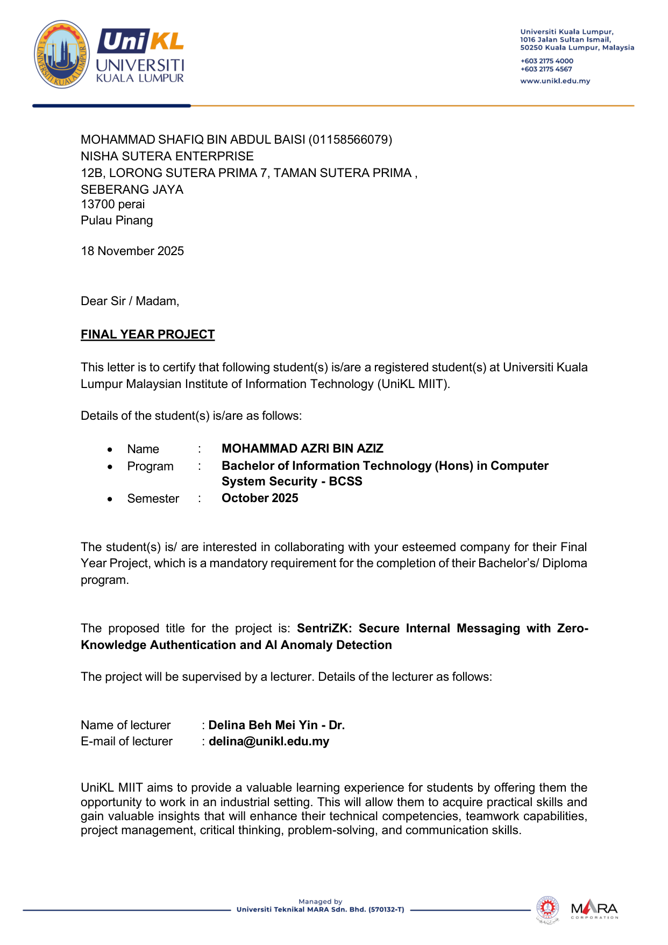

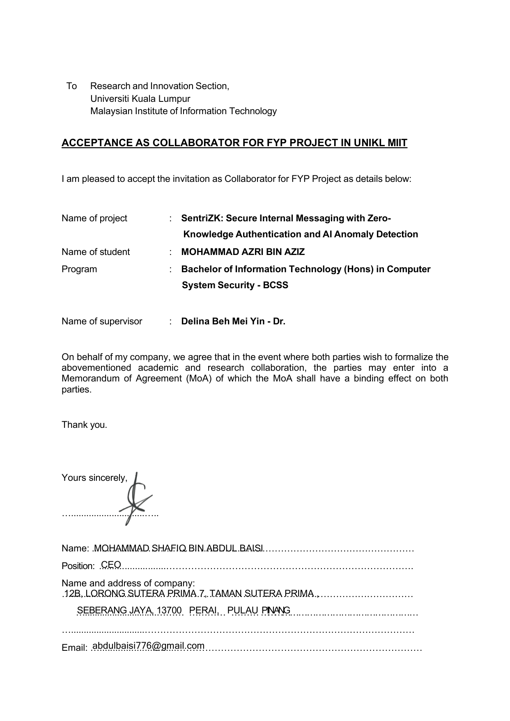


APPENDIX B: SOURCE CODE REPOSITORY
The complete source code for the SentriZK secure messaging system — including the Flutter mobile application, the Next.js web portal, the Node.js backend, and the Python machine-learning pipeline — is publicly available in the following Git repository:
https://github.com/mohammadazri/SentriZK-InternalChat

